uinuiai ruuiiuauun ui mluh—mu ii itci i.lauuuoi MDDuuiauun

**UILJJIUI**

ecember 2004

rhe Future is

earn how **Electronic**

Iccess Control has opened  
ip new and more  
**irofitable** door

hardware markets

**in** page 10.

# * % $ # $ # £ rfr $ & & # & $ & $ *_jj* *jqj* *y* 303

Breck H. Camp CML

**PLUS!** The E-plex 5000 secures the LUinston-Salem Forsyth County School System-paye 28

**RISO** in this Issue: Greg Perry and a Dudley LUall Safe, Electronic Field Hides, Part 3 of 3 in Eric Costley’s Pickset Series, Product Reuieujs, Marketing Vour Business Effectiuely, HLOH Pays

PO Box 47070 Atlanta GA 30362-0070

liillilliiiiilliilliiiililllf1111111111111111 f 1111111111 (11111

Tribute to HJ Hoffman and MORE!

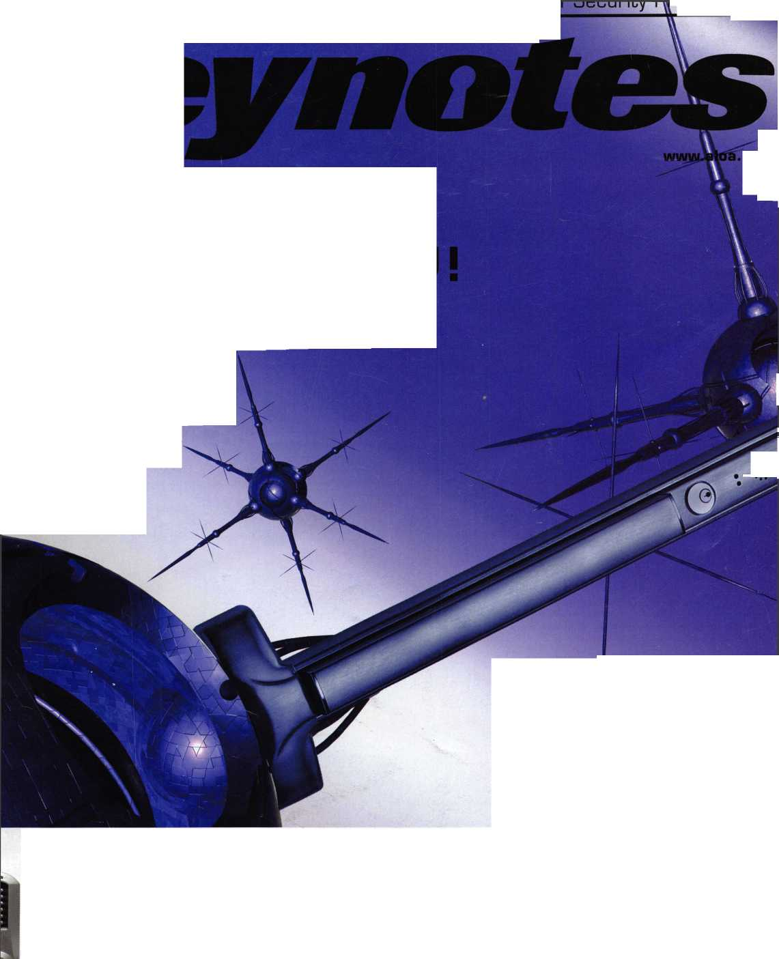

*An American Original*

Building on its 90-year tradition of quality, ingenuity and locksmith support, American Lock today delivers your security needs as never before.

Numerous innovations in padlock construction — including solid body locks, double-ball locking mechanisms, serviceable components and high-security cover plates — long ago established American Lock as the industry's security leader.

saving systems help make your life easier, and your operation more profitable.

**The best is yet to come.**

Now American brings renewed vigor to locksmiths everywhere, aided by joining forces with Master Lock during the past year ... with additional resources focused on developing new products and value-added services to further help you grow your business.

Unmatched services such as Make-to-Order capability, Lock Express™, key charting, custom marking, locksmith training, merchandising displays and other time­

Contact your distributor for details as they unfold.

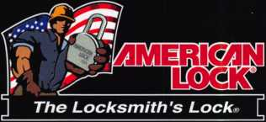

© 2004 American Lock Company

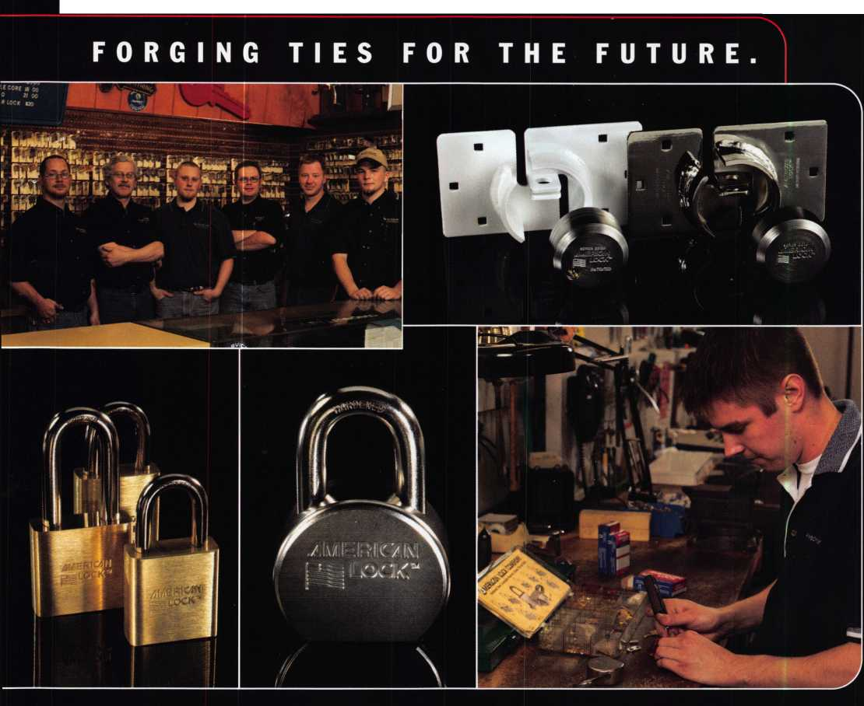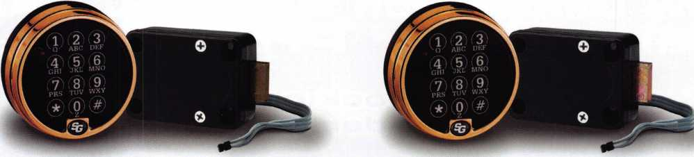

Before. After.

Can you see the difference?

**With our latest electronic locks, it’s what you can't see that really counts.**

**Download our Free Electronic Safe Lock Guide Today!**

**[www.sargentandgreenleaf.com/guide.pdf](http://www.sargentandgreenleaf.com/guide.pdf)**



**SARGENT ANDGREENLEAF**

A lock on security.

**Continuous improvement and smart design are a way of life  
at S&G. Improvements like our new deadlocking capability  
that provide an even higher level of security and durability  
in boltwork blocking applications.**

**And all of our electronic locks offer innovative features that  
make them more reliable, secure, and easy to use. Features  
like our advanced, motor-driven design that guard against  
bouncing and vibration attacks. Simple, yet clever innovations  
like putting our keypad connector outside the safe for  
convenient servicing. And the unique advantage of easily  
programming our locks using only the keypad.**

**Our electronic lock family is the broadest in the industry.**

**And it’s built tough and designed to fit most any commercial-  
grade application you may encounter. But most important,  
they’re all hacked by the S&G customer service and support  
that’s always there when you need it.**

**So, if you haven’t tried one of our electronic locks lately,  
contact your S&G Distributor and see the difference.**

**[www.sargentandgreenleaf.com](http://www.sargentandgreenleaf.com)**



**New Generation STAR XL CAN**

lost my Taurus keys... you make me a new set?'

NGS STAR XL CAN Locksmith 8008LXLC

\/ much of your money eyou sent to the il Ford Dealer?

you Know... e Dealers charge an rage of $100 per isponder key?

>u can get the factory isponder tool for less i the cost of doing one per month?

Use what the Dealers use for complete  
coverage on ALL Ford/Lincoln-Mercury and  
Mazda vehicles equipped with transponder  
keys. The NGS XL CAN offers complete  
transponder coverage including CAN protocol  
and the ability to clear ALL Diagnostic Service Codes

e never on>wurown :reeTechmca Suddo

**S004 Software Update and CAN Vehicli  
Interface Module now available.**

**© Waekon/Hickok Inc. 2004 All rights**

**reserved.**

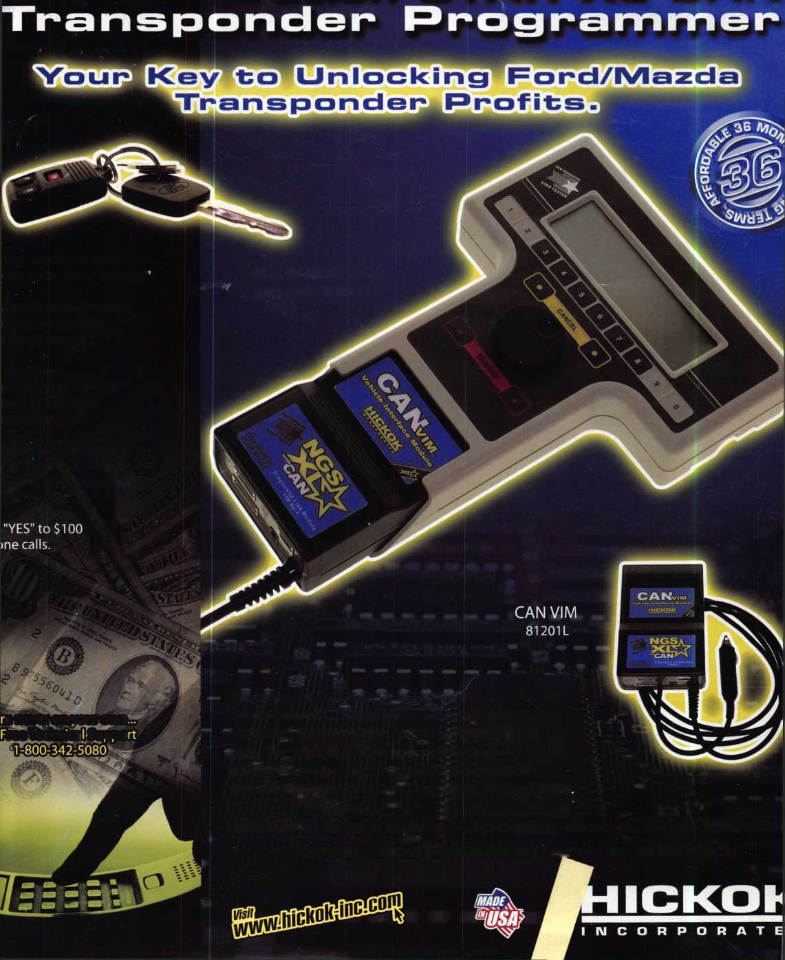

The 0afc and Vault Technicians assodataion  
donnention and Trade jShom

March 6-/2, 200S

*Hyatt Regency, Locingten /(/*

!>

Ml rey Mac, keeping up with the latest the industry has to offer has never  
been more important for us safe technicians. Let me tell ya, you gotta stay  
aware of what today's top safe distributors and manufacturers are putting out  
there. It's crucial to making a humdinger of a purchasing decision, buddy.  
And another thing, time is of the essence when it comes to education. New  
things pop up every day, Daddy-O, and that makes top-notch safe classes  
as good as gold. The only chance to get world-class education and meet  
with the industry's top distributors and manufacturers is the SAFETECH  
Convention and Trade Show. Boy, is it swell! SAFETECH 2005 offers you  
a chance to meet with potential customers and bolster business in ways  
you never thought possible. Discover the safes of tomorrow! Gee whiz,  
jump and jive your way into Safetech 2005, and you'll be part of our  
knock 'em, sock 'em show of all shows!!

*Safetech Oisits Seautifui Lexington, Kentuckgl*

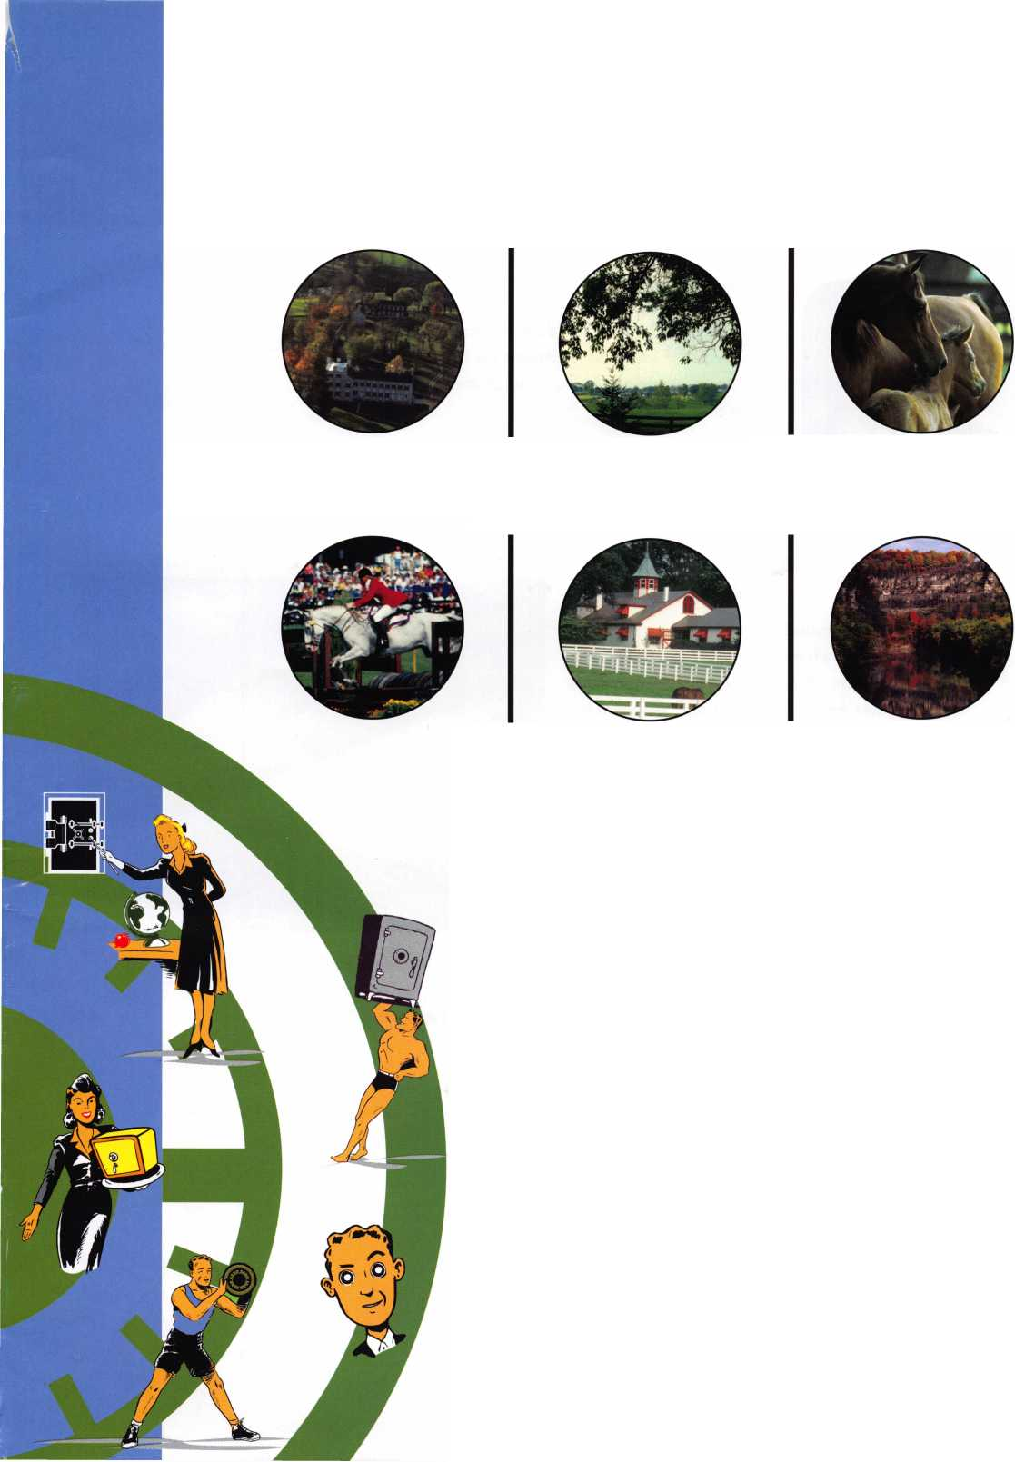

presidential

viewpoint

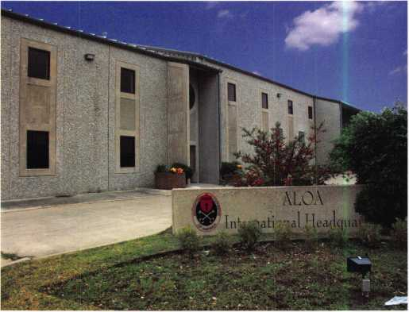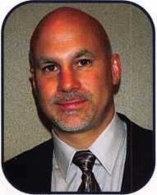

Proposed New Property

The existing headquarters in the downtown area was purchased  
several decades ago. ALOA really doesn't need a downtown loca-

tion and, with real estate prices escalating, this proved to be the

perfect time to sell. We are getting much more building for our dollar and one that is better suit-

ed to our needs. And, our moving expenses will be covered

in the process!

The new building is located in an industrial/corporate park.  
It will have plenty of office space, warehouse storage, room  
for a larger museum, and most importantly, classroom space!  
This move paves the way for an "in-house" education pro-  
gram and also allows us to accept more donations of lock  
collections and museum pieces.

As I am writing this, I am completing the final details and  
agenda for the fall board meeting. There are many impor-  
tant issues that we will be discussing. One of the most impor-  
tant issues is PRP Recertification and requiring new members  
to become certified within a specified time frame. I am very  
excited about this program. It will obviously benefit ALOA

but, there will be a widespread effect that will help local associations, the trade publications,  
help us establish relationships with manufacturers and national service providers, and advance  
our legislative efforts. The end result will be a highly trained and professional membership. This  
is how we intend to market ALOA and its members in the near future!

Dear Members,

I have some exciting news from down in Texas. ALOA has signed  
an agreement of sale on our headquarters at 3003 Live Oak Street  
and signed a contract to purchase another building in the  
Dallas area.

Your board of directors has a vision for ALOA and the plan is starting to come together. Com­pany membership, recertification, professional standards, business education, the ALOA Cer­tified Security Center program, and our legislative efforts all tie in to make this a very exciting time to be an ALOA member.

Sincerely,

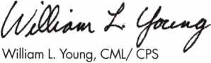

President

Keynotes • December 2004

SWEET

Get Ready for RLOR 2005,

a powerful resource to explore innouation and form industry alliances. This year we’ue thought of euerything from an exciting location, comfort­able accommodations and a conuention center that is equipped to handle your euery need.

Located just minutes from downtown  
Chicago, Rosemont, Illinois is the  
perfect “business uillage”, designed specifically  
to make your stay conuenient, comfortable  
and aboue all, successful!

The 49th Annual RLOR Conuention and Security Expo  
offers top-notch classes, workshops, networking  
opportunities and cutting-edge technology.

Rnd don’t miss out on the fine dining and enter-  
tainment options that Chicago has to offer. Shop  
at the world-famous Magnificent Mile. Eat at  
Morton’s of Chicago or Harry Caray’s Italian  
Restaurant. Uisit the Nauy Pier or catch a ball  
game. The options are endless when you register  
today for the single-most important euent in  
the locksmithing industry.

Baby, you knoui you want to yo!



Sweet Home Chicago

features

ELECTRONIC ACCESS CONTROL 2004

10

Electronic Door Hardware...

The Future is Here

With the appearance of economical, reliable, and easy-to- use and install electronics such as CPU boards, "chips", computers, touch pads and sensors, door hardware moved into a new plane. Now, electronics can be utilized to solve a myriad of door hardware requirements.

by Jake Jakubuwski

**14**



**30**

Dudley Doesn't Work Right

Greg Perry investigates a broken Dudley Wall Safe. Both the dial and the handle were frozen on this very simple locking system with wheels that have a fence lever that is pushed up into the wheels by the lower rod of of the U- shaped boltwork. What would you do to open this safe?

by Greg Perry, CML, CPS

No Strings Attached

With the advent of laptop computers, the codebooks and service manuals have slowly slipped into storage. Now, with the stroke of a few buttons, the locksmith can access just about anything he needs. Key codes, service proce­dures, key blank and part applications, catalogs, etc., are now contained within a tiny little box and accessible at the touch of button. All this is available, provided the software is purchased and properly installed, by Tom Seroogy

What's in Your Pickset?: Specialty Picks

**26**

**28**

(Pt. 3 of 3 in the Pickset Series from October 2004)

Every pick is a "specialty pick". Each development and every individual invention was designed intentionally to meet a specific need. Some of these innovations have proven invaluable in a variety of situations, by Eric Costley, crl

Review: SafeData Electronic Index

Many of us strive to be on the cutting-edge of technology. The problem has always been knowing where the edge is. reasearching and storing clippings, codes and other infor­mation is a necessity. With these massive amounts of infor­mation, how do we retrieve what we need quickly?

The Safe Data Electronic Index solves this problem and should be a lynch pin for anyone's computer-based library.

by Jym Welch, CPS

K-12 Medical Records Secured

One of the main biggest priorities for the Winston-Salem Forsyth County School System is the security of the medical records stored onsite. The E-Plex 5000 makes the grade for solving this complex problem.

**32**

**42**

What Does Your Yellow Pages Ad Say About You?

Greg Perry discusses ways to evaluate your Yellow Pages marketing and decide whether or not it is worth the

expense, by Greg Perry, CML, CPS

The Industry Pays Tribute to Anthony J. Hoffman

Locksmiths find comfort in sharing their thoughts about a legendary collector, Keynotes contributor, and professional

locksmith. by John T. Grist, CML, CPS

|  |  |
| --- | --- |
| r | 1 |
| AD INDEX | |
| American Lock | Inside Cover |
| Detex | 13 |
| Keedex | 15 |
| Professional |  |
| Business Products | 17 |
| T-Core | 7 |
| SafeData | 27 |
| Kaba Acess Control | 29 |
| Turn 10 | 36 |
| Lockman Tools | 37 |
| A&B | 37, 41 |
| S&G | Inside Back Cover |
| Hickok | Back Cover |
| L | J |

**Departments**

|  |  |  |  |
| --- | --- | --- | --- |
| Presidential |  | Calendar | 8 |
| Viewpoint | 2 | Core | 9 |
| Executive | 5 | Classified  Associate | 36 |
| Applicants | 6 | Members  Legislative ... | 38  40 |

Visit our website at [www.aloa.org](http://www.aloa.org)

executive

Volume 50, Issue 11

Additional contact information for the ALOA Board and most Keynotes authors is  
available through "Locksmith Search'" on the ALOA Web site- [www.aloa.org](http://www.aloa.org) or by  
contacting the ALOA office at 3003 Live Oak Street; Dallas, TX 75204; (800)532-2562;

FAX (214)827-1810; e-mail [aloa@aloa.org](mailto:aloa@aloa.org).

Publications Manager

Betty Henderson [betty@aloa.org](mailto:betty@aloa.org)

Technical Editor

David Lowell, CML, CMST [david@aloa.org](mailto:david@aloa.org)

Editorial Advisor

John Cannon, CML [jcannonl@cox.net](mailto:jcannonl@cox.net)

Advertising Sales

Kim Hammond voice: 817-645-6778

Fax: 817-645-7599  
e-mail: [adsales@aloa.org](mailto:adsales@aloa.org)

Executive Director

Charles W. Gibson, Jr., CAE [charlie@aloa.org](mailto:charlie@aloa.org)

Associate Executive Director

David Lowell, CML, CMST [david@aloa.org](mailto:david@aloa.org)

Convention & Meetings Manager

Jo Anne Mims [joanne@aloa.org](mailto:joanne@aloa.org)

Operations/Membership Manager

Mary May [mary@aloa.org](mailto:mary@aloa.org)

Contributors

Jerome Andrews, CML Ray D'Adamo, CML

Paul Chandler, CRL Billy Edwards, CML

Claire Cohen, CML Dan Graffeo, CRL,CMST

Brian Costley, CML, CMST Jim Hancock, CPL

Eric Costley, CRL Jeff Nunberg, CML, CMST

Mission Statement: The Associated Locksmiths of America, Inc. is dedicated to enhancing the professionalism, education and ethics among  
locksmiths and those in related sectors of the physical security industry. With approximately 10,000 members in the United States, Canada and the  
freeworld, ALOA is poised to help members obtain the knowledge, the strength, and the confidence to perform their role in the physical security field  
with pride and dignity. But it is only through active involvement and participation that ALOA can fully achieve its potential—and can help members to  
achieve theirs.

Policies: Keynotes® is the official publication of the Associated Locksmiths of America, Inc. (ALOA). Keynotes® acts as a moderator without approving,  
disapproving, or guaranteeing the validity or accuracy of any data, claim, or opinion appearing under a byline or obtained or quoted from an acknowl-  
edged source. The opinions expressed by the authors do not necessarily reflect the official views of ALOA. Also, appearance of advertisements and  
new products or service information does not constitute an endorsement of products or services featured by the Association. The Association does not  
accept responsibility for the inaccuracy of any data, claim, or opinion appearing in this publication, due to typographical errors on the part of the  
authors, Association staff or its agents.

Editor's Note: This publication is designed to provide accurate and authoritative information in regard to the subject matter covered. It is provided  
and disseminated with the understanding that the publisher is not engaged in rendering legal or other professional services. If legal advice and other  
expert assistance is required, the services of a competent professional should be sought.

Authors' Payment: Payment for eligible submissions to Keynotes will be based on the following criteria: topic, time spent and past contributions. Authors who  
regularly submit to Keynotes® are generally paid a higher rate. The latter is especially true of authors who write to fit specific editorial needs and submit said copy  
by Keynotes® deadlines. As a general guideline: Average payment for a 750 word, business or 'light' technical article would be $200. Payment for a 1500 word  
article involving significantly higher time and research efforts would be $400.

Payment will not be offered for articles submitted by ALOA employees or members of the ALOA Board of Directors (unless material is of a technical  
nature), nor for articles submitted by a company that promote that company's products or services. ALOA reserves the right not to pay for articles sub-  
mitted by an individual(s) that promote a particular company's products or services.

Disclaimer: The Associated Locksmiths of America, Inc., (ALOA), reserves the right to refuse any article for any reason. Additionally, ALOA reserves  
the right to edit, amend or modify any article submitted for publication in order to preserve technical accuracy, clarity, fairness or grammatical cor-  
rectness. ALOA will make the best efforts to notify the author of any changes. The extent of ALOA's liability for any article or information contained  
therein will be a notice of correction or retraction in the next possible issue.

Keynotes® (ISSN 0277 0792] is published monthly except for the combined June/July issue by The Associated Locksmiths of America, Inc.,  
3003 Live Oak St., Dallas, TX 75204-6186. Telephone: (214) 827-1701; FAX (214) 827-1810; e-mail [aloa@aloa.org](mailto:aloa@aloa.org). Subscription rates for  
members—$15.00 per year. Periodical class postage paid at Dallas, Texas. POSTMASTER: Send address changes to: Keynotes, 3003 Live Oak St.,  
Dallas, TX 75204-6186. © Copyright 2003, All rights reserved. No part of the contents may be reproduced or reprinted in any form without prior  
written permission of the publisher.

Government Relations Manager

Paul Kanitra [paul@aloa.org](mailto:paul@aloa.org)

IT Operations Manager

Greg Jackson [greg@aloa.org](mailto:greg@aloa.org)

Comptroller Kathy J. Romo

Membership Coordinator Shelly Jett

Convention & Meetings Assistant Karen Lyons PRP/Education Coordinator Hope Rodriguez

Accounting Coordinator

Mail Room Coordinator Kevin Wesley

Publications Coordinator Bryan Dease

Executive Assistant Sue Langford

Receptionist Wendy Wilder

Randy Simpson, CML, CPP Tom Seroogy Robert Stafford, CML Charles Stephenson, CPS

Dave Thielen, CML Dennis Watanabe, CML, CMST

Greg Perry, CML,CPS



President

William L. Young, CML  
(610)647-5042  
[president@aloa.org](mailto:president@aloa.org)

Secretary

John Soderland, CML, CMST  
(414) 327-5625  
secreta ry@a loa.org

Directors, Northeast

Robert E. Mock  
(856) 863-0710  
nedi rector@a loa. org

Peter Sarailian, CRL  
(973)890-9797  
nedirecfor@aloa .org

Vernon Kelley, CPL  
(609) 771-3126  
nedirecfor@aioa .org

Directors, Southeast

Tom Gillingham, Jr., CML, CPS  
(615)264-0747  
[sedirector@aloa.org](mailto:sedirector@aloa.org)

Ken Kupferman, CPL  
(813)961-5784  
sedirector@aloa .org

Director, North Central

Mark E. Blum, CML, CPS  
(517) 482-5809  
[ncdirector@aloa.org](mailto:ncdirector@aloa.org)

Director, South Central

CD Lipscomb, CML, CPS  
(903)874-3522  
scd i rector@a loa. org

Directors, Southwest

Gordon R. Racine, CML  
(719) 384-4707  
swdirector@a!oa .org

Julie McCluney, CRL  
(714) 636-5652  
[swdirector@aloa.org](mailto:swdirector@aloa.org)

Director, Northwest

Jim Jeffries, CPS  
(208)743-1 101  
[nwdirector@aloa.org](mailto:nwdirector@aloa.org)

Director, European

Hans Mejlshede, CML  
(453)539-3939  
[eurdirector@aloa.org](mailto:eurdirector@aloa.org)

Director, Asian

JoeJ. Lee, CRL  
(215)289-2404  
[asiandirector@aloa.org](mailto:asiandirector@aloa.org)

Director, Associate

Paul M. Justen  
(800)333-6953  
[asdirector@aloa.org](mailto:asdirector@aloa.org)

Trustees

[trustees@aloa.org](mailto:trustees@aloa.org)

Randy Simpson, CML  
(281)240-5959

John J. Greenan, CML, CPS  
(773) 486.2030

Past Presidents

2001 -2003 Randy Simpson, CML  
1999-2001 John Greenan, CML, CPS  
1997-1999 Dallas C. Brooks  
1995-1997 David Lowell, CML, CMST  
1993-1995 Breck Camp, CML  
1991-1993 Henry Printz, CML  
1989-1991 Evelyn Wersonick, CML, CPS  
1987-1989 Leonard Passarello, CPL  
1985-1987 Joe Jackman, CML  
1983-1985 Stanley Haney, CPL  
1981-1983 Louis LaGreco, CPL  
1979-1981 John Kerr, RL  
1977-1979 Clifford Cox, CML  
1974-1977 Charles Hetherington  
1972-1974 Gene Laughridge  
197a 1972 William Dutcher, RL  
1968-1970 Constant Maffey, RL  
1966-1968 Harold Edelstein, RL  
1964-1966 William Meacham  
1962-1964 Robert Rackliffe, CPL  
196GT962 Edwin Toepfer, RL  
1956-1960 Ernest Johannesen



Keynotes • December, 2004

Chandler

Jesse Riley

Sponsor: Enrique B. Olivares

*CA*

Santa Rosa

Ralph C. Bell

Sponsor: Craig B. Hackney

*CO*

Colorado Springs

Clarence L. Doughty

Sponsor: Peter W. Ordway CRL

Fort Collins

John Stoody

Sponsor: Raymond J. D'Adamo CML

CT

North Haven

Antonio DiPalma

Sponsor: David Gardetto

Wethersfield

Mark Dragone

Sponsor: William L Young CML, CPS

DC

Washington

Fara B. Koroma

Sponsor: Michael C. Olson CRL

FL

Boynton Beach

Ricky J. Newman

Sponsor: Robert W. Duman Sr, CML

Orlando

Scott H. Wilburn

Sponsor: *Elias* DeHoyos

Chicago

Rickey L. McDonald

Glenview

Michael J. Russell

Oak Lawn

Blanca Castorena Carlos R. Lancerio

Rock Island

James A. Whitcomb

Sponsor: Jerry R. Robinson

Wheaton

John W. Miller

Sponsor: William T. Beranek

KY

Radcliff

Deborah L. Jenson

Sponsor: Eric D. Jenson

MA

Greenfield

Ronald J. Lefebvre

Sponsor: Scott N. Phaneuf CRL

Williamstown

Glenn Rougeau

Ml

Grand Rapids

Scott Martin

Kalamazoo

Larry K. Gillam

Sponsor: Lonnie G.

McKinney PhD, CML Sponsor: Todd A. Phillips CRL

Madlena M. Ewert

Sponsor: Todd A. Phillips CRL

MN

Minneapolis

John P. Sullivan

Sponsor: Sandy Sproat

Florissant

Brian P. Smith

Saint Peters

Robert Brown

NC

Raleigh

Brandon D. Tucker

Sponsor: Granger L. Mar ley CML

NE

Omaha

Jerald V. Schroeder

Sponsor: Elvis D. Hammerschmidt CPL

Pelham

Brian Emond

Sponsor: Steve Joyal

NJ

Franklinville

Veronica McCabe

Sponsor: Vernon Kelley CPL, CIL

Whiting

Jessica L. Porter

Sponsor: Peter Sarailian CRL

Albany

Alfred J. Gabriel Jr

Sponsor: William L. Young CML, CPS

Altamont

John Cullam

Sponsor: William L. Young CML, CPS East Berne

Paul H. Whitbeck

Sponsor: William L. Young CML, CPS

Bethlehem

Karen J. Brice

Sponsor: James T. Brice CRL

Sponsor: Donald A. O'Shall CPL

John W. Rendle

Sponsor: Donald A. O'Shall CPL

Folsom

William P. Price III

Sponsor: Peter Sarailian CRL

Woonsocket

Peter R. Toupin

Sponsor: William L. Young CML, CPS

VA

Arlington

Arthur Romero

Sponsor: Michael B. Groves

Fredericksburg

Larry Dockery

Sponsor: Michael B. Groves

Spotsylvania

William C. Salvas

Sponsor: Michael C. Olson CRL

Wl

Sheboygan

Todd A. Martin

Sponsor: Robert W. Oestreich RL

id

Solihull, West Midi

Jason Rainey

Sponsor: Ken Dale

South Africa

Cape Town

Randell De Wee

Sponsor: Ian R. Grade

These applicants are scheduled for clearance as members of ALOA. The names are published for member review and comment within 30 days of this Keynotes issue  
date, respectively, to ensure applicants meet standards of ALOA's Code of Ethics. Protests, if any, should be addressed to the Membership Department and must be  
signed. Active Membership applicants (a) have worked in the industry two or more years. Allied Membership (AL) applicants are not locksmiths, but work in a security-  
related field. Apprentice Membership (AP) applicants have worked in the industry less than two years.

Keynotes • December 2004

iC C03E LKJliBClHn

For all 6 & 7 pin SFIC cylinders including Best, Falcon, Arrow & others.

..Herculite doors  
without pulling them  
down.

..cabinet lock to  
convenient thumb latch  
operation.

double cylinder lock  
to single cylinder.

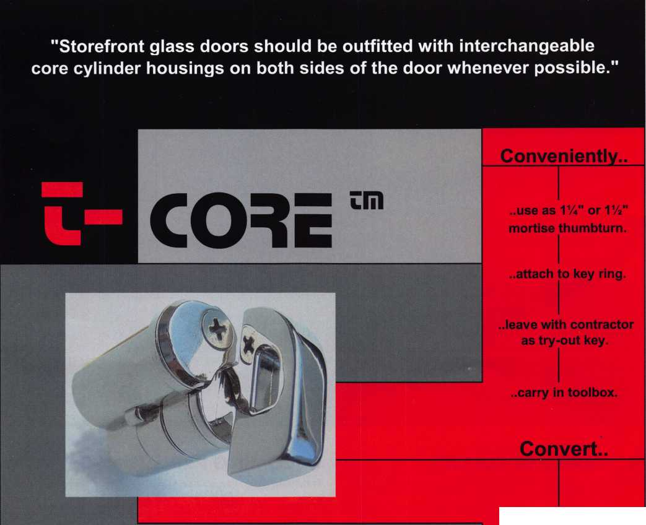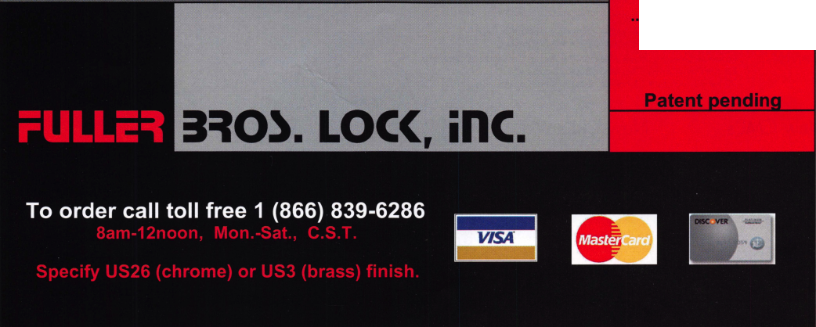

p c o m

events

u

i n g

|  |  |
| --- | --- |
| 1 Ohio Valley Chapter of ALOA  Monthly Meeting  Ryan's Steakhouse  Middleton, Ohio  513-464-1299 | 6 Minnesota Chapter of ALOA 8 New York Master Locksmiths' Assoc. 14 Fox Valley Chapter of ALOA  Annual Banquet, Dinner 6:00 PM, Monthly Meeting Meeting 6:00 PM  No Meeting NYC/Long Island Area Columbus Club, Appleton  718 274-6930 Steak and Strattec Night |
| 12 New York Master Locksmiths' Assoc. Monthly Meeting  NYC/Long Island Area  718 274-6930 |  |
|  |  |
| 9 New York Master Locksmiths' Assoc  Monthly Meeting  NYC/Long Island Area  718 274-6930 |  |
|  |  |

UPCOMING ACE CLASSES

12/4/2004 Birmingham, AL • Alabama Locksmiths Association • DLee Schofield

334-832-4920 • Simplex Unican Certification

1/5-16/2005 Kalamazoo, Michigan • West Michigan Locksmiths Assn

R. Paul Bentley, CPL 269-327-8400 • Small Format 1C w/L-38 PRP Large Format 1C w/L-39 PRP

2/12/2005 Detroit, Michigan • Locksmiths Security Association

Robert C. Nobel, CPL 810-385-9329 Complete Door and Door Closers w/L-05 PRP

2/19-20/2005 Kalamazoo, Michigan • West Michigan Locksmiths Association

R. Paul Bentley, CPL 269-327-8400 Motorcycle Locksmithing w/L-22 PRP

2/25-27/2005 Minneapolis, Minnesota • Minnesota Chapter of ALOA •

Dana Lee, CML 612-968-4500 • 5 ACE Classes

3/3-6/2005 Somerset, New Jersey • Master Locksmiths of New Jersey Annual

Convention & Trade Show • Bill Timmann, CML, 908-839-3135 21 Ace Classes

3/19-20/2005 Kalamazoo, Michigan • West Michigan Locksmiths Association

R. Paul Bentley, CPL 269-327-8400 Combination Lock Manipulation (2 days)

4/28-30/2005 Denver, CO • Central & Southern Colorado Locksmiths Assn

Gordon Racine, CML 719-384-4707 • 9 Ace Classes

7/17-24/2005 Rosemont(Chicago), Illinois • ALOA 49th Annual Convention & Security

Expo • David Lowell, CML,CMST 800-532-2562 xl8 70 full day classes • 35 half day classes & evening seminars

UPCOMING PRP SITTINGS

12/9/2004 Thursday 8:30am • Dallas, TX • ALOA Hope Rodriguez

800-532-2562x30

2/26/2005 Saturday • 9:00am Roseville, Ml • Locksmith Security Assn

Robert Noble, CPL 810-385-9329

2/27/2005 Sunday 9:00am • Denver, CO • Central & Southern Colorado

Locksmiths Assn • Gordon Racine, CML 719-384-4707

2/27/2005 Sunday 9:00am • Maplewood, MN • Minnesota Chapter

Dana Lee, CML 952-887-1199

3/5/2005 Saturday 8:00am • Somerset, NJ • MLANJ 200 • Bill Timmann, CML

908-839-3135

3/12/2005 Saturday 8:00am • Lexington, KY • SAFETECH 2005

Hope Rodriguez 800-532-2562x30

3/26/2005 Saturday 8:00am • Corpus Christi, TX • TLA Convention

Ed Stites 979-240-9083

7/22/2005 Friday 6:00pm • Rosemont, IL ALOA 2005 • Hope Rodriguez

800-532-2562x30

10/09/2005 Sunday 9:00am • Orlando, FL • SERLAC 2005 • James Barnhardt, RL

813-689-5979

|  |  |  |  |  |
| --- | --- | --- | --- | --- |
| New CML's | New CRL's | DOHERTY, PETER M. WATERFORD, CT | COFFMAN, MICHAEL D. Portland, OR | ROWEDDER, LEE W. Kearney, NE |
| BOWMAN, DALE | HUMPHREYS, JOHN K | KVALE, IAN J. | THURSTON, ALAN | TODD, DONALD E. |
| Salem, VA | Ledyard, CT | Bloomington, IN | McMinnville, OR | Bettendorf, IA |
| LAIRD, AGNES, P. | ROBERT, ALAIN H. | TRAIL, LARRY L. | WYMAN, STEVEN S. |
| WECHTER, ROGER S. Norwalk,CT | Rutland, VT | Waltham, MA | Port Orchard, WA | Plant City, FL |
| DOWNING, BRYON E. Denver, CO | RUSSO, MARTIN G. Nashva, NH | BRAUGHT, DARYL  Scappoose, OR |  |
| New CPL's | KERNS, JEFFRY S. | BOYD, HARRY A. | REEDER, JEREMY J |  |
| GARDNER, GEORGE R. | Auburn, KS | Bremerton, WA | Boise, ID |  |
| North Ferrisburg, VT | CHAMPAGNE, STEVEN H. Middlefield, CT | BLACK, JESSE B.  Monroe, WA | FRITZ, DONALD S.  Cedar Rapids, IA |  |

**core**



In Memory of Alan Brown

I lost a friend and the locksmith industry lost  
one of its finest gentlemen when Alan Brown  
of Ireland passed away at the young age of  
41 on Sunday, October 24, 2004. Alan suc-  
cumbed to a heart attack while returning with  
a group of locksmiths by ferry from an Auto  
Locksmith Association (ALA) in the United  
Kingdom.

Alan was the owner of Brown Brothers  
Locksmiths in Dublin and was in the lock busi-  
ness for 20 years. His business, with a staff  
of 8, will continue to operate.

Alan was a past president of the Associated  
Locksmiths of Irelands and he was a member of  
ALOI, the European Locksmith Federation,  
MLA-Great Britain, ALOA, and ALA. Alan trav-  
elled to Chicago for the ALOA convention in  
2002. He recently stepped down from the  
ALOI board to spend more time with his family.

ALOI Convention-February 2004  
Alan Brown far left, Dave O'Toole 2nd from left.

The funeral for ALan Brown was huge, with more than 1500 people attending. Every major locksmith company in Ireland was represented and many locksmiths and suppliers travelled from the UK and mainland Europe to pay their respects.

Alan is survived by his wife, Ann and they five children (aged 10-16). Please keep them in your prayers.

I will always remember Alan for his dedication to his craft and even more for his love of family and passions in life. Rests in peace, Alan. You are deeply missed by all.

In Memory of Don. J. Spenard, Sr.

Don J. Spenard, Sr. was born in Seattle on  
May 1, 1917 and died peacefully surround-  
ed by his loving family on October 15,

2004. He spent his early years around the  
Lake Union waterfront living on houseboats.  
He was a lifetime Seattle resident.

Don was one of the first employees of  
Argen's Safe and Lock Company of Seattle,  
from which he retired in 1983. He was a  
self-taught Master Locksmith and a safe and  
vault technician. He was highly respected  
nationwide for his knowledge of the trade.

A sought-after professional by Federal, State  
and Local Authorities for high-security lock  
and safe work, Don was instrumental in the

training and certification of many professional locksmiths throughout the years.

A man well known in the Seattle area for his ability to crack a safe, Don was a  
founding Life Member of the Northwest Locksmith Association and the Tri-Regional  
Locksmith Association. He was also a charter member of the Association

Locksmiths of America and a member of the Safe and Vault Technicians  
Association. Don served as a technical consultant to his fellow tradesmen  
to the end.

Don's interests and volunteer activities spanned many ares and years. As a volun-  
teer fireman in King County Fire Protection District #5, he rose to the rank of  
Captain, serving for 15 years until the City annexed the area. Don was also a  
member of the Central Puget Sound Fire Association.

An avid boater, Don was a founding member of Puget Sound Outboard Cruising  
Club, now Puget Sound Yacht Club, of which he is now a Life Member. He was  
very active in boating activities and a trustee and past president of the Inter-Club  
of Gavel. One of Don's accomplishments while president of Inter-Club was the  
acquisition of Sucia Island and other islands in the San Juans as permanent recre-  
ation areas for boating. Don was a permanent member of the Coast Guard  
Auxiliary, with retired status, where he used to teach navigation and safe boating  
practices. Don was also very active in Boy Scout programs with his children.

In later life, Don enjoyed his motor home and travelled extensively. He was a member of Ballard Elks Lodge #827 and Rambling Antlers RV Club. He was also a Life Member of Eagles Aerie #1 since 1940.

Preceded in death by his wife of 55 years Jessie (Koncan) Spenard and a great- granddaughter, Don was a loving mentor and father to his children, John Spenard, Donna Watters, Donald Spenard Jr., and Betty Conklin, seven grand­children, and four great-grandchildren. In addition, he will also be missed by two nieces, a nephew and a host of extended family members and friends who loved him.

Bill Young and Alan Brown at  
Bradenburg Gate  
Berlin, Germany • May 2004

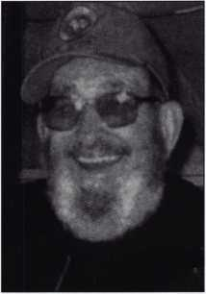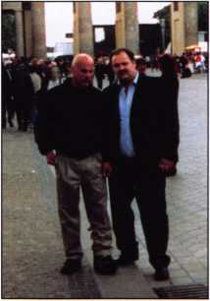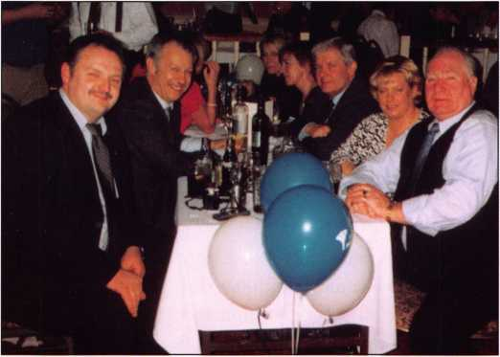

Bill Young, President ALOA

Electronic Door Hardware

The Future is Here

by Jake Jakubuwski

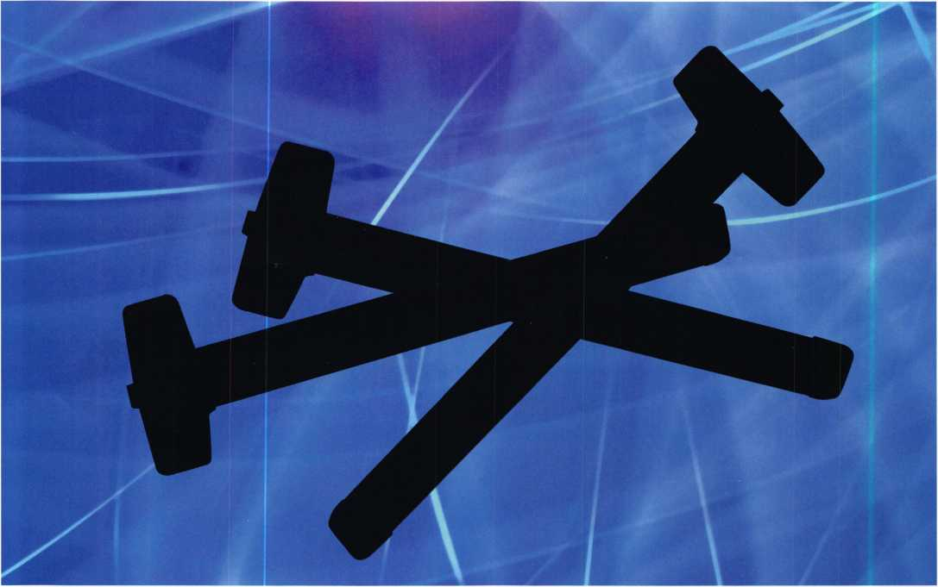

Whether designing, specifying, ordering or installing door hardware—specifically access and egress hardware—there are several criteria you must keep in mind.

Everything from aesthetics to the Americans with Disabilities Act influences the form, function, finish and feasibility of the hardware used. Therein lies the rub.

The multiplicity of design, specifying, ordering and installing mandates—as well as client requests—makes it difficult to develop an all-inclusive, comprehensive, secure door hardware package. That is a package that will meet all of the codes and considerations required by the various jurisdictional mandates: as well as client needs.

From the time our ancestors rolled a large rock in front of their cave to keep enemies and things that go bump in the night at bay—the quest for ever more secure means of pro­tection against ever more sophisticated threats has been an obsession. Mankind has been engaged in a multi-milleni- um crusade to improve their physical safety, well being and the secure preservation of their possessions.

In a strictly mechanical sense, todays locks and door hard­ware have shown little change from the locks and door hardware of a hundred years ago. Sure, we have better materials, brighter finishes more secure keyways, more dependable mechanisms, sleeker design aesthetics and some innovative functions not available in the early years of the last century. However, a mechanical lock is just

Keynotes • December 2004

that—mechanical. Because it is a relatively straightforward mechanical device, designed to control access and egress, it is limited with respect to its functionality and ability to meet various code mandates.

Throughout the history of mechanical door hardware (par­ticularly, during the last hundred years or so) the tendency has been to add more bolts, levers, pins, bars, latches and gizmos to the door to make it more secure. With the advent and near universal adoption of Life Safety Codes— and more recently the ADA—physical security and code compliance became a more arduous goal to achieve. Not impossible...but decidedly more difficult.

pants. The major problem, of course, was allowing access to the premises by customers or employees without sacrific­ing security concerns. Hardwired buzzers, strikes—as well as doormen or armed security personnel—were early answers to those security concerns.

However, the real breakthrough in marrying code compli­ant door hardware and security considerations came with the appearance of practical, low-cost electronics, which readily permit a virtual endless variety of functions. No longer were manufacturers, architects, contractors and installers dependent on the physical activation of physically oriented hardware.

That difficulty was nowhere  
more evident than on  
perimeter doors where codes  
dictated a simple, one-  
motion egress standard while  
“tight” security called for  
multiple point locking and  
hard-to-defeat locking mech-  
anisms.

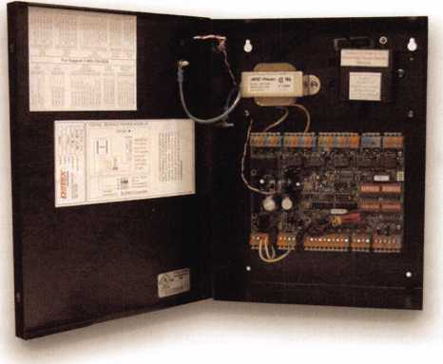

For instance:

An auditorium, with multiple banks (or sets) of doors, might be equipped with electronically dogged panic devices. Such an arrangement would allow for the conven­ience of simple push/pull operation during the day and offer secure electronic re-latching during “events”, or at night, with a simple “flip” of the switch. In a slightly more sophisticated format, selected doors might be scripted to grant access at various dates and times with electronic latch retraction! Other easy-to-accomplish scenarios might be latch bolt monitoring, door “open” status displays, elec­tronic access with card or proximity card activation, access (and egress) audit trails.

But those scenarios are only the beginning. We re seeing more and more timed access and delayed egress, covert cameras, “smart locks”, latch-monitoring exit devices and central station monitoring that might “control” a single door or thousands of doors around the world!

As panic hardware develop-  
ment progressed—spurred by  
the need to keep a building  
secure and yet safe—more

advanced concepts became reality and allowed more secure  
locking of exit doors with better code compliance features.  
Simple battery operated (or hardwired) circuits allowed for  
exit devices that would sound an alarm when the device  
was activated or attacked. With more sophisticated devel-  
opments in alarmed, monitored doors, and CCTV easier  
monitoring of those doors became a reality.

Paralleling the enhancement of mechanical, door exit hard­ware, mechanical access control concepts were refined as well. From primitive arm-holes cut in a door to allow manipulation of the bolt with a sickle-shaped key, to a “latch string” and ultimately multi-point key-operated mechanisms, to dual-custody, paracentric keyways, and digital locks: the quest for security continued unabated.

The evolution of secure mechanical access hardware was less irksome, in many respects, than the exit hardware development since virtually any type of device or lock could be used on the access side of the door.. .as long as it didn’t interfere with the free egress of the building’s occu­

With the appearance of economi-  
cal, reliable and easy-to-use and  
install electronics such as CPU  
boards, “chips”, computers, touch  
pads and sensors, door hardware  
moved onto a new plane. Now,  
electronics could be utilized to  
solve a myriad of door hardware  
requirements! And that fact alone  
(the development of what we  
ambiguously refer to as “electronic  
access”) has opened up new and  
more profitable door hardware  
markets.

Keynotes • December 2004

There can be little doubt that electronic access and egress door hardware readily allows for more efficient, code (Life Safety and ADA) compliant and secure configurations than ever before possible. There can be little doubt that with the continued improvement and development of “electronics” that the potential and probabilities of even more effective, easier-to-use, and secure electronic door hardware configu­rations and products are virtually limitless.

Factoring in electronics as an integral part of door hard­ware requirements becomes not only more practical as more sophisticated electronics make their advent—it becomes a necessity. With todays concerns about physical security, the door hardware industry is faced with enor­mous challenges and even greater opportunities.

The challenges are presented as a result of increased popu­lations, the demand of the working, traveling and buying public for safer and more secure environments for those pursuits. From the employers, merchants and transporta­tion provider’s standpoint, the challenges are evident in their efforts to meet the needs of their customers and employees; as well as to prevent theft of goods, services and technology.

Those challenges are further exacerbated by factors as diverse as the cost of labor, industrial espionage, pilferage, domestic and foreign terrorist concerns, OSHA, ADA, rampant litigation over real or perceived wrongs and, not the least of these, overall increased operating costs.

The tendency of commercial, industrial and governmental entities to operate with fewer and fewer people as a result of controlling labor costs, and the myriad safety and secu­rity issues presented by modern society demand practical, dependable and cost-effective answers. Electronic door hardware and its functional adaptability go a long way to meeting the challenges faced by Americas public, commer­cial, industrial, educational and governmental organiza­

tions. In fact, electronic door hardware is rapidly becoming a factor in the residential arena as well as the commercial marketplace.

Today, the opportunities are there for the savvy, market- oriented firm that is willing to address the challenges that are presented by security-conscious businesses and organi­zations of all genres. Elbert Hubbard once said that to be successful all one had to do was “Find a need and fill it!” The need is there. It can be filled by electronic door hard­ware, economically and quickly.

Today, the technology is in place and begging to be uti­lized. In fact, if you think about it, a modern CPU “board” in a relatively “simple” electronic lock, or exit device, has more computing power then was available to the entire world in 1948! Considering that, there is no longer any valid reason that door hardware cannot be secure, effective, aesthetically pleasing and code compliant.

Today, because of the advances in electronics and its use by the door hardware industry; the architect, specification writer, purchasing agent, builder, contractor and door hardware installer have more options, covering more con­tingencies, than ever before in the history of door hard­ware.

Today, because of the user-friendly nature of modern elec­tronics, there is an abundance of electronic and electro­mechanical door hardware products that offer combina­tions of code compliance and security that have never before been available.

Today, that hardware is even more attractive because it is offered at prices that make its utilization not only reason­able but also affordable and cost-effective.

Today is yesterday’s future. Today, when it comes to elec­tronic door hardware—the future is here!

**2**

Keynotes • December 2004

**ARCHITECTURAL**

**HARDWARE**

**LOSS PREVENTION  
PRODUCTS**

**ACCESS CONTROL**

E5

Trust Detex to make the bad guys do time with its new, extra-secure delayed egress package.

Life Safety & Security Door Hardware

800-729-3839

830-629-2900

[marketing@detexcorp.com](mailto:marketing@detexcorp.com)

wvwv.detex.com

Now Detex puts together superior security and highly reliable life safety with its new electromagnetic delayed egress package.

Detex delivers an extra measure of life safety and security to your back door by packaging a rim device with a built-in logic board and an overhead electromagnetic lock for extra-reliable delayed egress. Its extra-reliable because it does not depend on a delayed mechanical function. Its perfect for doors requiring interior life safety and loss prevention plus highly secure exterior access.

CHECK THE SPECS

Detex EM Packages

* Available in the Value Series
* Pre-configured Packages with

One Order Number, Ready to Install

* Proven, Trouble-Free Easy Installation
* Tandem Holding Force of a 1,500 Pound Mag Lock and a 1,400 Pound Exit Device
* 15-Second Delay Allows Time for Security Response
* lOOdB Audible Alarm Operates with 24-volt AC Power
* Remote Signal Capability for System Integration and Central Monitoring
* Exceptional Manufacturers Warranty

PUSH UNTIL ALARM SOUNDS

DOOR CAN BE OPENED IN 15 SECONDS

SMART RIM ■ EASY INSTALLATION ■ DEVICE +

1

S OF PUSH ■ uniMMTFW **&** VflMIF SflfflL-iinfBl

Life Safety,  
Security and  
Security Assurance

BELAYED

Need life safety with an extra step of security?

Lock down with the new EM package from Detex,

where we ve been meeting or exceeding codes for life safety and security door hardware for over 40 years. Call or visit

the Detex website.

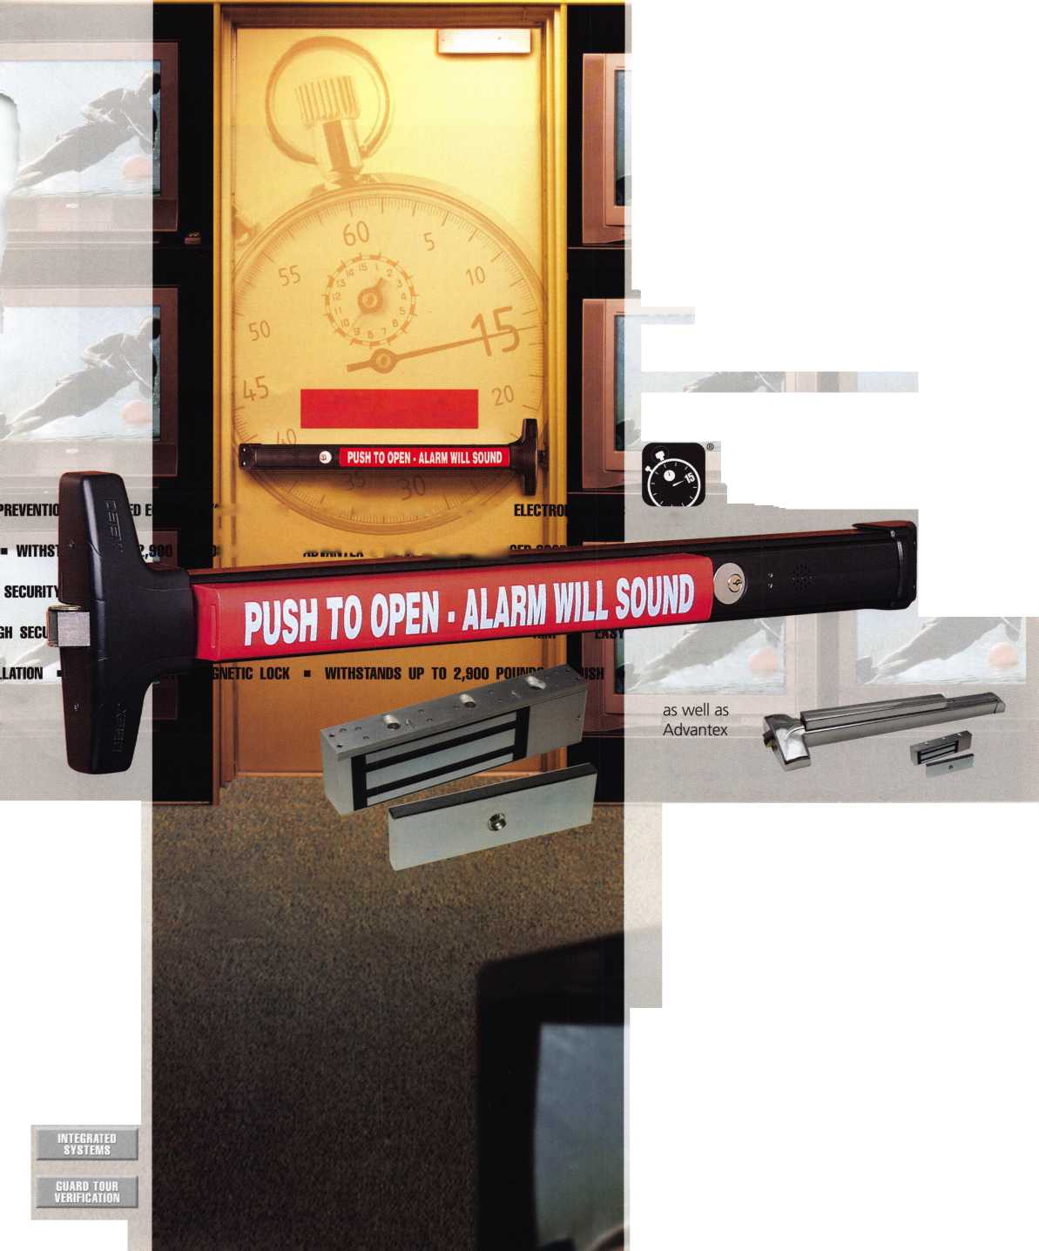

Dudley Doesn’t Work Right!

by Greg Perry, CML, CPS

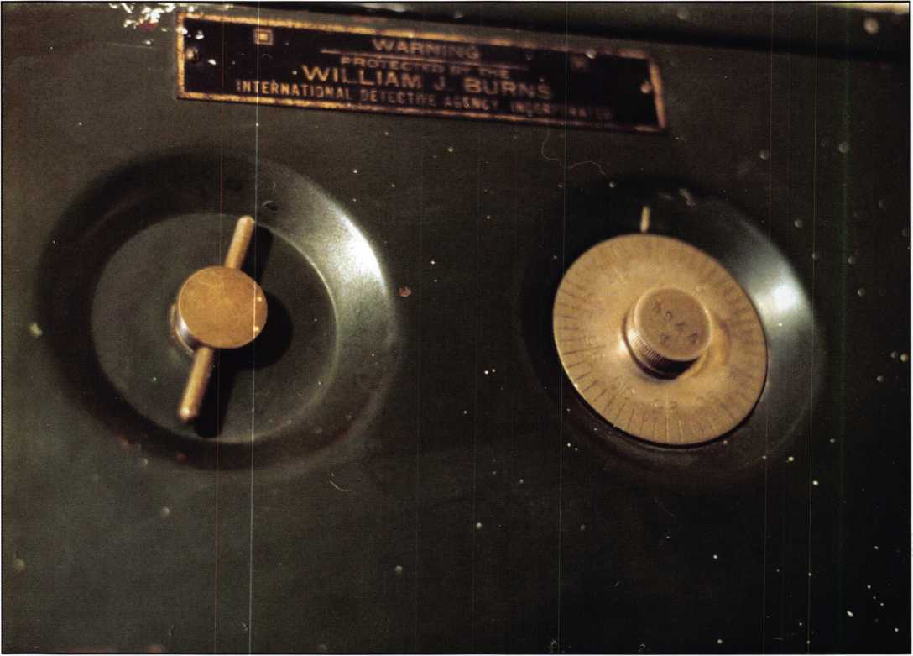

Photo 1, the wording on the outside of the safe is "Warning Protected by the William J Burns International Detective Agency". This is probably either a dealer or just a diversion label.



Keynotes • December 2004

It’s not often a family member needs a safe-  
cracker, but my brother had a wall safe he  
couldn’t open. He knew the combo but  
both the dial and the handle would not  
turn. His house was built in the early  
1940’s and he believed the safe was  
installed when the house was built. My  
guess was the safe was manufactured by the  
Murphy Wall Bed Company but that was  
based on age since I’ve only seen pictures of  
a Murphy. My brother lives over 3 hours  
away so I considered having a friend stop  
and take care of opening it but that doesn’t  
give me the satisfaction I crave. I also want-  
ed pictures and details for my database so I  
agreed to go.

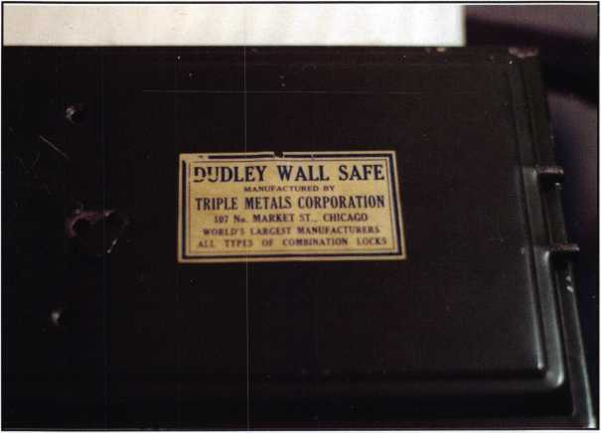

Photo 2 the backside of the door provides the real model and manufacturer, Dudley Wall Safe - Triple Metals Corporation.

My brother sent a picture and I posted it on the SAVTA web site since it didn’t match the Murphy pictures from other sources. One member nailed the safe with pictures and a little info. His information was helpful but still did not answer the question of why the dial would not turn. I suggested the old “hammer on the door trick” to see if anything would free up. It didn’t, so I planned a trip to go see him.

When I got there, I found the safe as described. Both the dial and handle were both frozen. I looked at the pictures from the SAVTA web site. The safe has a very simple locking system. The wheels have a fence lever that is pushed up into the wheels by the lower rod of the U-shaped boltwork. What would you do to open this safe?

**New!** Keedex Stainless Steel Armored Door Loops

AVAILABLE FROM YOUR KEEDEX DISTRIBUTOR

MADE IN U.S.A.

ALL

STAINLESS STEEL

DESIGN

STAINLESS

STEEL CONDUIT

STAINLESS STEEL  
END PIECES

STAINLESS STEEL

MOUNTING SCREWS

COSTS NO MORE  
THAN MOST DOOR  
LOOPS THAT HAVE

PLASTIC END PIECES

Call or write today for your free catalog!

Ideas That Work"

Keedex, Inc.

12931 Shackelford Lane  
Garden Grove, CA 92841  
714-636-5657 • Fax: 714-636-5680  
e-mail: [info@keedex.com](mailto:info@keedex.com)

[www.keedex.com](http://www.keedex.com)

Keynotes • December 2004

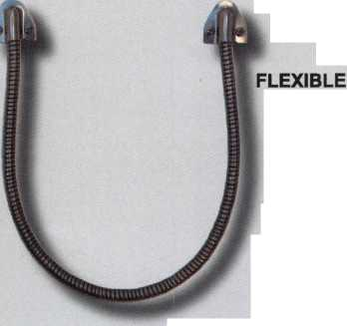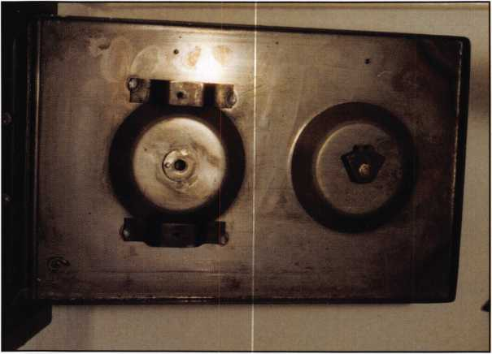

Photo 3 takes us inside the door to the backside of the face. The dial connection to the wheel pack is made with a drive pin on the left side. The right side han­dle cam is upside down in this picture. It contacts the cutouts in the topside of the bottom bolt.

My first guess was that the boltwork was jammed-partially locked but not quite all the way. This might explain why the dial did not turn. Looking at my options, I fig­ured if a small hammer didn’t work, grab a bigger one. Then I thought perhaps it is more important to grab a soft face dead- blow hammer. Deadblow hammers are filled with shot (or bbs) that move to the back of the hammer as the hammer swings. When the hammerhead hits the surface the shot inside slams into the hammerhead to impart force and to keep the hammer from bouncing back. Two swings of the hammer later, while at the same time turning the handle, it started to move. A couple more and the safe door swung open.

After removing the back panel, we found a sheet of off-white fibrous material that apeared to be asbestos. I assumed it was added for fire resistance, although I doubt it offered much protection. The problem turned out to be the arm (or lever) that moves in and out of the wheel pack. It was almost frozen. The wheel pack was also very stuff. Both the lever and wheel pack were riveted in place, preventing removal. The only thing we could do was apply pen­etrating oil to help free things up.

**6**

Keynotes • December 2Q04

After taking the pictures and getting  
dimensions of the safe, we reassembled the  
back cover leaving out the fibrous material.  
Then we tested it a few times. It worked,  
although I didn’t think it will ever work  
smoothly. Looking inside the safe we found  
it was made by the Dudley Wall Safe Mfg.  
by Triple Metals Corp. of Chicago Illinois.  
According to the label, they were the  
largest manufacturer of all types of combi-  
nation locks. I’m certain the wheel pack  
and basic design is similar to their combi-  
nation padlock design. The 3 wheels and  
drive cam are only 3/4” in diameter and  
the gates look like they could also be used  
to catch the cutout in a padlock shackle.  
The dial is a 50 number dial and the U  
shaped bolt is 1/4” round stock.

Opening this safe should be easy; the lock  
if its functioning properly should manipu-  
late easily turning the handle forces the  
fence into the wheels. A scope hole drilled  
anywhere just outside the dial in the area of  
4:00 o’clock or 15 to 20 on the dial will  
give you a great view of the wheel pack,  
then simply transfer the numbers to the  
about 27 to open.

No pay on this job after all he is my broth-  
er. But I got to get some more information  
about a safe I’ve never seen before and  
write an article to pass on the information  
to you in case your brother should call you  
needing his wall safe opened.

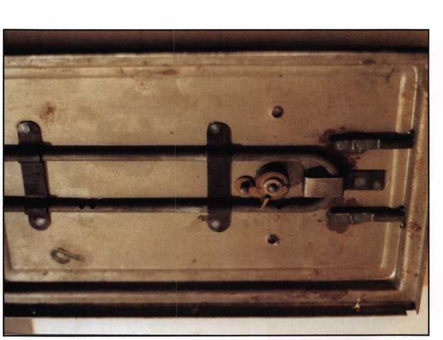

Photo 4 shows the wheel pack and U bolt, the insulation sheet was found between the two halves of the door.

**ADVERTISE WITH  
OUR**

**WEATHERPROOF**

**LABLES**

Professional Business Products

We donate 5% of all sales to the  
**ALOA Scholarship Fund**Buying from NEBS®?

We offer lower prices on invoices/workorders, checks,  
repair tags, magnets, business cards, key tags and more.

[www.pbp2000.com](http://www.pbp2000.com)

Keynotes • December 2004

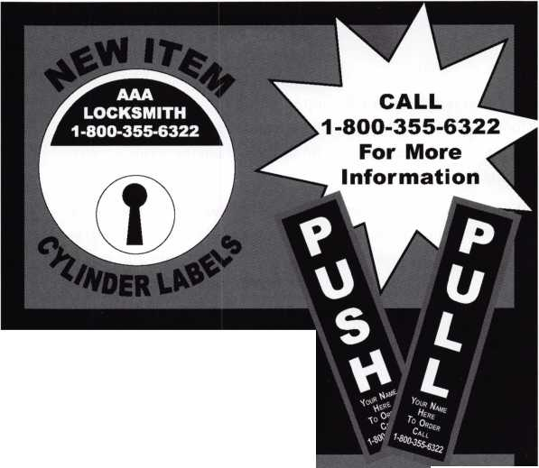

No Strings Attached

By: Tom Seroogy

On a recent trip, while waiting  
for my plane to depart, I gazed  
intently across the gate area at a  
gentlemen furiously typing  
away on a miniature two-piece  
keyboard. Folded in half, the  
keyboard was about the size of a  
deck of cards.

More intriguing than the key-  
board, however, was the small  
satellite dish sitting on the table  
next to the keyboard. Barely the  
diameter of a baseball, the dish  
enabled this individual access to  
the internet without the need  
for wires or Wi-Fi. Needless to  
say, the ability to connect to the  
internet and email allowed this

individual to turn normally unproductive time into productive.  
More importantly, the sight of these little gadgets (and we all  
love gadgets) caused the cogs up in the old engine room to start  
turning.

I’ll admit, I can remember the time when most of the space in a locksmiths van was used for storing codebooks and service man­uals. In fact, if automotive was your forte, codebooks and manu­als easily outweighed all of the key blanks, replacement locks, service kits, and locksmith equipment added together.

With the advent of laptop computers, the codebooks and service manuals have slowly slipped into storage. Now, with the stroke of a few buttons, the locksmith can access just about anything he needs. Key codes, service procedures, key blank and part applica­tions, catalogs, etc., are now contained within a tiny little box and accessible at the touch of button. All this is available, provid­ed the software is purchased and properly installed.

Well, here I am sitting in an airport staring at what could be the next step in the evolution of locksmith “data acquisition” (big word for the “information” needed to do a job). Now, instead of purchasing, installing and updating software; envision immediate access to the latest version of all the information needed by sim­ply accessing the internet from inside your service vehicles?

Get Connected

Connecting is not all that difficult. If money is no object, satel­lite connection may be the best bet. With relatively high down­load and upload speeds, satellite’s only drawback is locating an

available satellite or connecting during bad weather.

For the more frugal - myself included - a data connection sub­scription with Nextel is all that is needed. Simply purchase the auxiliary USB cable and use your Nextel phone to connect to the internet. Be warned, however, this type of service is used for sim­ple data transfer and is not recommended for web connection. Top data connection speeds on this service are only 9 kbs, far below the more common 56 k speed of standard phone modems, and far slower than broadband. (See photograph 1.)

If satellite doesn’t trip your trigger, and the 9 kbs data connec­tion is not adequate, many cell phone providers offer web con­nection services - although some at a premium price. Do your shopping for the product and service that fits your need and budget.

Nextel and other providers offer a wide variety of wireless web hardware and software options. For the purposes of the general locksmith, Nextel’s iM 1100 Wireless Modem Card and the Packetstream Gold package are more than enough to work the web from the field; offering a 56K modem for $350.00 and unlimited downloading for around $55.00 per month.

Applications

Once connected, what’s available for the locksmith? Well, the following are a few web applications and services to take a look at. Some of these are free, others are subscription based. Either way, the benefits may be well worth your time to explore.

Blackhawk Programs - [www.lockcodes.com](http://www.lockcodes.com) OEM Web Sites - [www.nastf.org](http://www.nastf.org) Locksmith Forums -

[www.internetlocksmith.com/www.clearstar.com](http://www.internetlocksmith.com/www.clearstar.com) General Searches - [www.google.com/www.yahoo.com](http://www.google.com/www.yahoo.com) ALOA.ORG— [www.aloa.org](http://www.aloa.org)

Blackhawk - [www.lockcodes.com](http://www.lockcodes.com)

For years Blackhawk has been offering locksmiths quality key code and other locksmith related programs. Although I may stand to be corrected, Blackhawk is the first (and still the only company) to offer these same programs as subscription based web (and web phone) applications, and at a fraction of the cost of standard computer based software (See photograph 2). Programs available include:

Codes On Line (CODES)

Key Blank Cross-References (KBX)

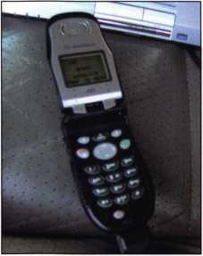

1: Web access from the field is  
easier and cheaper than ever.  
Locksmiths can take great advan-  
tage of all the internet has to offer  
by simply getting connected.

**8**

Keynotes • December 2004

Pin any Small Format Interchangeable Core (SFIC)

Fill On Line (FILL)

Lock Name Listing (NAME)

Combination Counter (CC)

Frequently Asked Questions

Two programs offering great benefit to the locksmith include the Codes On Line and the recently introduced Fill On Line.

To find a code, simply go to [www.lockcodes.com](http://www.lockcodes.com) and select the Codes On Line link to open the code program. From here the process is straightforward.

Enter the code and your preferred key machine or depth/space format. We’ve chosen the 1200CM and the Ford 8-Cut key code 170IX (See photograph 3).

The next page allows the user to refine the search by choosing the types of codes they want or by simply choosing the desired series from the list box. In this example there are 33 Automotive code series and 1 Office/other series available. With our code readily displayed in the list box, we simply select “Ford Taurus transponder 1998-99” (See photograph 4).

The final page displays the key bitting, applicable key blanks, and the specifications for the selected key machine (See photo­graph 5).

Especially applicable for automotive locksmiths, the Fill On Line application takes a known set of cuts and produces a cutting tree for progressioning a final key. In our example, we’ll use the depths of the first six spaces of our Ford 170IX key code.

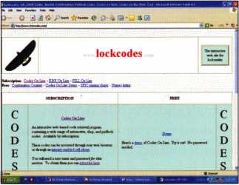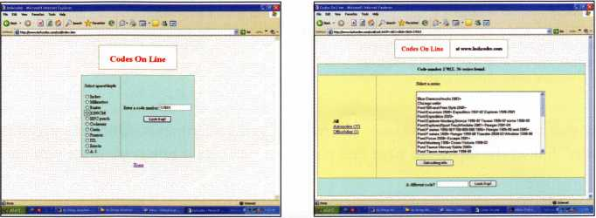

2: A pioneer in offering web-based locksmith solu- 3:Codes On Line offers the locksmith quick

tions, Blackhawk subscriptions are economic alter- access to key codes,

natives to PC based solutions.

4: Using Codes On line is straightforward and  
simple.

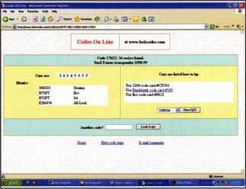

5: A few quick steps and the key code bitting and other pertinent information is displayed.

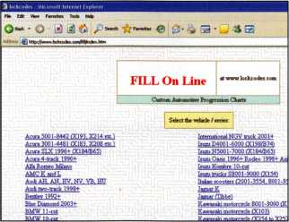

6: Fill On Line is the perfect compliment to the  
Codes On Line application, and especially useful  
to the automotive locksmith.

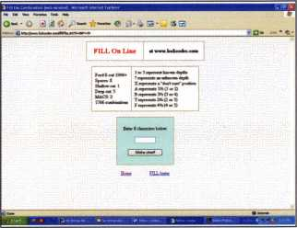

7: Simply select the series of the  
bitting desired.

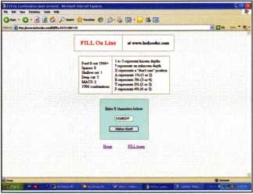

8: Insert the depths of the known spaces along with "?" for each unknown space.

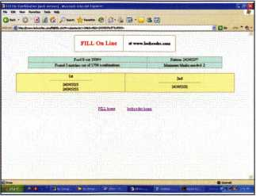

9: As quick as you hit the button, a list of pro-  
gression charts are produced.



Keynotes • December 2004

Clicking the Fill On Line link takes us to the first page of the application. Here we select the key code series from which our cuts originate. Again, our example uses the Ford 8-Cut 0000X-1706X code series (See photograph 6).

Clicking the link of the appropriate code series, we are directed to the bitting input page (See photograph 7). Simply enter the known bitting into the text box at the bottom of the page. Make sure to put “?” question marks for the unknown depths, or “X” for spaces we re not concerned about. In our example, the first six depths are known, and we want to know the last two cuts. So, we

enter - 243453?? (See photograph 8).

Entering this number produces several charts  
that allow us to progression a working key  
using the least number of key blanks. (See  
photograph 9.)

OEM Web Sites - [www.nastf.org](http://www.nastf.org)

Some of the best automotive resources avail-  
able over the net are the technical web sites of  
the original manufacturers. Instead of listing  
each, however, I have simply supplied a link  
to the National Automotive Service Task  
Force. While you can read about the purpose  
and goals of this entity from their own site,  
one of their accomplishments is to work with  
all the major automotive manufacturers to

deliver web based service information and training to the aftermarket. Once you get to this site, simply click the “OEM Service Websites” link at the top of the page (See photograph 10). This brings us to the web links for just about every automotive manufac­turer in North America (See photograph 11)

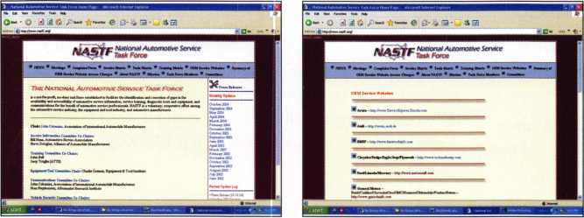

10: Heavily involved in obtaining automotive  
tools, information and training for the  
aftermarket, the National Automotive Task Force  
also offers the technical sites for all available  
automotive manufacturers.

1 1: Available for the locksmith's perusal and  
use, a listing of all the automotive manufacturer  
web sites.

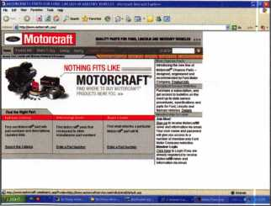

12: Ford is a favorite site.

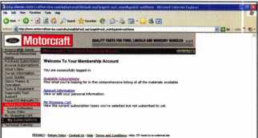

14: Once signed in, you have access to sub-  
scriptions and other information.

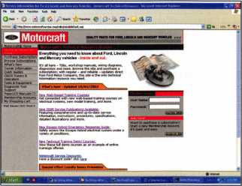

13: Sign up for an account is free and  
allows access to some of the free,  
but useful, information.

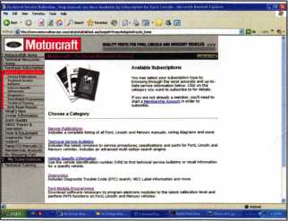

15: The ability to program transponder keys from  
the internet is one feature unique to Ford.

Before going further, it should be noted that  
every manufacturer site is different. Each one  
offers different subscriptions in different for-  
mats. Not all sites are intuitive or easy to use,  
so it may take a little hunting to access the  
needed information. It should also be men-  
tioned that none of the manufacturers offer  
access to key codes or PIN numbers.  
However, several offer transponder key pro-  
gramming and keyless remote programming  
procedures and information.

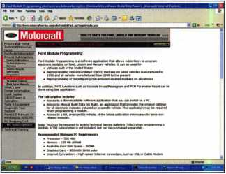

16:

For our example, we’ll pick the Ford/Lincoln/Mercury link - [www.motorcraft.com](http://www.motorcraft.com) (See photograph 12). To get to our technical information click the “Technical Resources” link along the tabs at the top of the page. From here the user is asked to sign in. If you have not previously signed in, the process is simple and free (See photograph 13).

Keynotes • December 2004

Once inside, were free to view available subscriptions (See photograph 14). Unique to  
Ford (and the biggest benefit of going to the Ford web site) is the ability for a lock-  
smith to program transponder keys using Ford’s Module Programming subscription  
and an approved J2534 device (See photograph 13).

From a commercial/residential standpoint, don’t forget all the information offered by  
the various manufacturers of commercial and residential hardware. A quick jump to  
Schlage - [www.schlage.com](http://www.schlage.com) - shows that they offer a wealth of information on hard-  
ware, applications, and installations (See photograph 16).

Locksmith Forums

Of all the benefits offered by the internet, the locksmith forums are among the best.  
Two well known forums include the subscription based Clearstar ([www.clearstar.com](http://www.clearstar.com) ),  
and the free Internet Locksmith ( [www.internet-locksmith.com](http://www.internet-locksmith.com)) (See photographs 17  
and 18). ALOA.ORG also offers great technical forums utilizing the latest in messaging  
technology

Open strictly to working locksmiths (are there any other kind?), membership to these  
forums requires proof that the subscriber is a bonafide locksmith.

Both sites offer a wealth of information and help from some of the top locksmiths in  
the world. Each includes forums and chat rooms where you can get information or  
answers to questions on just about anything locksmith related - and then some.

Need a quick answer to a service problem? Simply sign on and post your question.

In most instances, you’ll have an answer in a short time.

Of special benefit is the instant messaging capabilities of Internet Locksmith. Using  
this feature, locksmiths can communicate instantly, allowing you to carry on a full  
and complete conversation in real time.

Search Engines

Last but not least, don’t forget the available search engines. Two of the most common  
are Google ( [www.google.com](http://www.google.com)) and Yahoo ([www.yahoo.com](http://www.yahoo.com)). While not dedicated to  
serving the locksmith, these tools do offer the locksmith access to all avenues for get-  
ting questions answered.

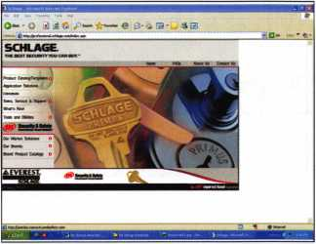

17: Schlage as well as other manufacturers of  
commercial and residential hardware also offer  
web based solutions.

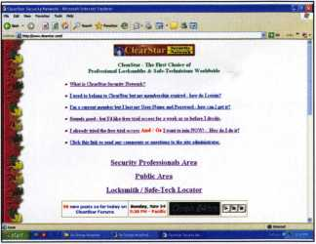

1 8: Subscription based Clearstar is among the more established locksmith forums available.

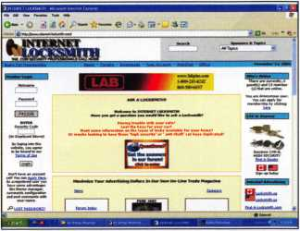

Associated Locksmiths of America

Home | Members Only

The Associated Locksmiths of America Inc. (ALOA) is an international professional organization of Neatly qualified security professionals engaged in consulting, sales, installation and maintenance of locks, keys, safes, premises security, access controls, alarms, and other security related endeavors.

Become A Member

ALOA. 2005 Convention

July 17-24 ; Rosemont, II. Hake sure to visit the convention website for more information, dick here

**New ALOA Locksmith Search**

The new locksmith search is up and running. Make sure you are feted - it only takes a few mutes1 click here

**Pictures from Baltimore! ALOA Online Education Member Directory**

An ALOA membership assures consumers that a locksmith upholds the highest business and ethical standards of practice. A.L.O.A Proficiency Certified Locksmiths have exhfeited a high degree of professional knowledge and ski in specific fields within the trade.

dick here to join

Visit Our Sponsors

Home | About Us | Calendar | Education | legislation | Convention j Store | Locksmith Search

Copyright © 2004 Associated Locksmiths of America, AS rights reserved.

19: Internet Locksmith is a free forum with instant  
messaging capabilities.

Get it All at the new  
ALOA.ORG!

A fresh new look Organized categories Brand new forums/ message boards with private messaging Improved members- only section and password selection tools

Calendar of Events Free Downloads Forms and Tools to build your business All-New ALOA Store Online Training And Much More!

Keynotes • December 2004

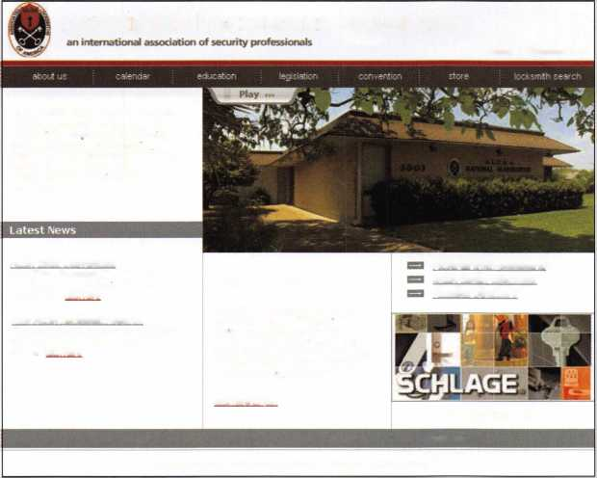

What’s in Your Pickset Pt. 3

Specialty Picks

By: Eric Costley, CRL

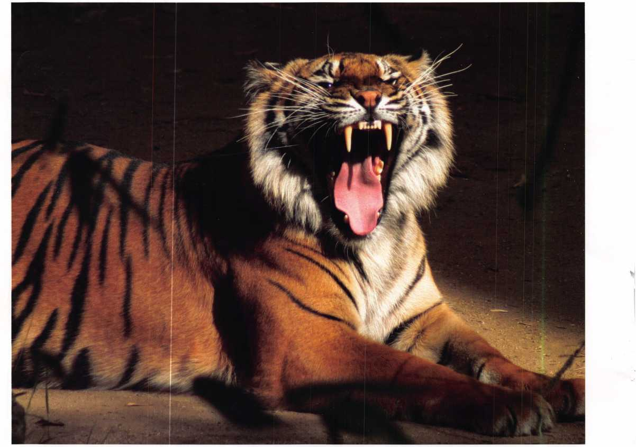

I have found the fiber picks to be the “cat’s meow”.

**22**

Keynotes • December 2004

In reality, every pick is a specialty pick. Each development and every individual invention was designed intentionally to meet a specific need. Even so, some of these innovations have proven invaluable in a variety of situations, and thus our “bread and butter” picks. Tension wrenches and plug spinners have undergone some interesting changes over the years, yet they remain a staple that no locksmith can do without. That brings us to our current topic, specialty picks.

Each time someone finds a way to bypass a lock, manufac­turers scramble to create something insurmountable. Each time a manufacturer comes out with a new product, lock­smiths respond by attempting to develop a tool to defeat that product as quickly and efficiently as possible. It is a vicious cycle that probably will see no end.

Not every product that hits the market lives up to the hype that surrounds it. After all, each manufacturer has spent money on development, patents, and the obligatory mar­keting blitz. The best and most effective way of choosing quality tools is to converse with others in your field.

Asking “What do you use?” and “What works best for you?” is not only perfectly acceptable, it should flatter the locksmith that you ask. After all, you are giving weight to his or her opinion! The “cloak and dagger” days of not dis­closing your “trade secrets” should be totally gone. As an industry, we will only survive and excel if we stick together. Okay, time to get off of my soapbox and get back to the subject. v

Specialty picks are simply that: picks which are designed for a specific lock and are pretty much useless if you try to use them to open (for instance) a Kwikset knoblock. Some of the most interesting innovations are mere novelties at best, yet the fact that they exist and are still marketed justi­fies their mention here.

The pick gun and its modern variation, the electronic pick, are two of the most common variations of our bread and butter picks. Both of these are designed on the “billiards” concept. In other words, a sharp knock to the bottom pin will send the top pin flying while the bottom pin remains stationary. (For those of you familiar with the laws of physics, an object at rest tends to remain at rest, and an object in motion tends to remain in motion, unless acted upon by other forces.) In the split second between the ini­tial smack of the pick gun or electronic pick, there is a sig­nificant gap between the two sets of pins. As long as this gap coincides with the shear line, the lock is picked! The

real trick with such tools is the application of feather-light tension, so as not to bind the pins in their individual chambers. These tools work best on locks such as Weiser, which have an inherently large gap between the top of the plug and the cylinder housing. With practice, they work well on a myriad of products.

One of the most common specialty picks is the tubular lock pick, which has found its way into virtually every locksmiths vast array of tools. There are a myriad of varia­tions on this basic concept, from the simple to the Petersen Pro-1. The latter is designed to defeat “dead pins” and varying spring tension in the Ace II variety of tubular locks. The choice of each locksmith depends on the num­ber of times one services such locks and the budget allotted for that particular application. (Personally, I drill tubular locks more often than not. It becomes a question of time versus money to replace in virtually every situation.) Many tubular picks use elastic bands to provide resistance against the spring-loaded pins in the lock. An interesting alterna­tive is the use of a piece of rubber hose, such as automotive vacuum hose, and a small hose clamp. This variation pro­vides an easy and uniform tension adjustment that can be made by simply tightening or loosening the hose clamp by as little as a fraction of a turn with a screwdriver. Once again, necessity becomes the mother of invention.

Rocker picks are designed primarily for use with sidebar locks such as the ones used in General Motors vehicles since the thirties. Now, other auto manufacturers have fol­lowed suit and sidebar locks are used in GM, Ford, Chrysler, Saturn, and others. The idea behind a rocker pick is two-fold: either turning pressure is applied sporadically as the pick is rocked and worked in and out of the key way, or pressure is applied directly to the sidebar while the pick is manipulated in the keyway. I have known used car deal­ers and repo men who became quite proficient with rocker picks, but personally I find it difficult unless I have access to put pressure directly on the sidebar.

One of the most interesting developments in picks is HPCs computer picks. Developed sometime around 1980, the theory was by cataloging the profile of a myriad of keys, one could generate a small number of picks that would manipulate the majority of locks on the market. Although I have seen some success with these picks, I tend to think of them as more of a novelty than anything else. They are used in much the same manner as rocker picks, with tension applied and released occasionally as the pick is

Keynotes • December 2004

**23**

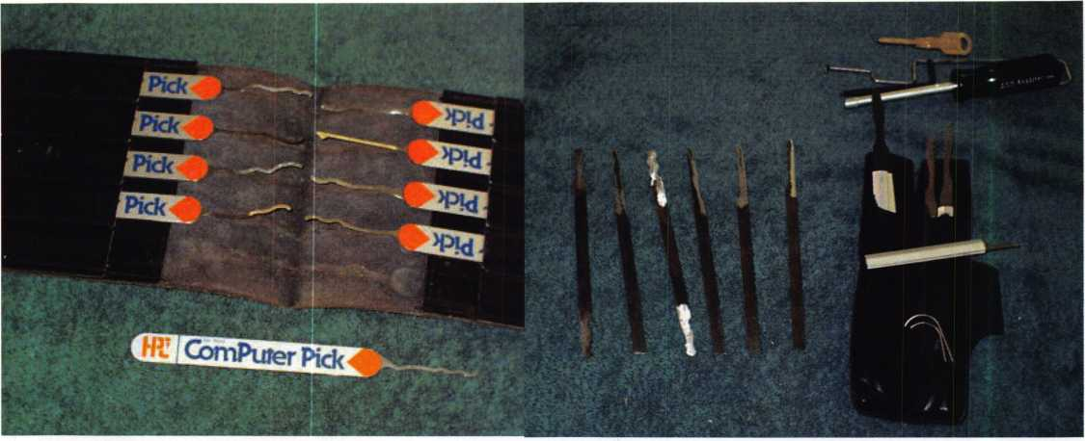

A set of HPC's computer picks.

A set of various rocker picks on the right, and A-l's set for picking the GM 10 cut ignition

on the left.

manipulated in and out of the lock. Of course, in the early 80s we were all under the impression that computers would make our lives easier, less complicated, and allow us to accomplish our tasks much faster. Most of us are now a bit more jaded and skeptical about such claims.

The most wonderful dynamic about our trade is that it is always growing, expanding, and thinking “outside the box.” Manufacturers are always attempting to develop something that will make a job simpler, easier, and more efficient. One of the most interesting developments that I have run across lately is the fiber pick, developed by Pickmasters. The theory behind this is not only valid, but also interesting that no one else has seen the need for such a product. If you are picking a lock that has a deep cut in the first pin position and a very shallow cut in the next position, you are pretty much “up the proverbial creek with no visible means of propulsion”. Although you may be able to lift that second pin to the shear line, you will probably push the initial pin up above the shear line in the process, and even the mere task of extracting your pick from the lock may put that first pin in the wrong position.

Virtually every conventional pick that is on the market today is made of spring steel. Although these will flex to some extent, they are rigid in construction. The fiber pick is basically a scaled down toothbrush, which means that if the first pin in our previous scenario is captured at the shear line, the pick will flex to move around it rather than pushing it out of the way.

I would like to say that I have found the fiber picks to be the “cats meow”. Unfortunately, after more than twenty years of dealing with conventional picks, I have found them awkward and tedious. Is this simply because I am accustomed to the feel of our bread and butter picks? To some extent, I would say yes, definitely. Pickmasters was generous enough to supply me with some extra goodies when I went to evaluate their product, and one of these was a cutaway cylinder. One of the things that I found amazing was that once a pin was manipulated to the shear line, it stayed there. Regardless of the position of other pins in the lock, a pin that was at the shear line never moved - despite the vigorous movement of other pins. Although I could pick the same cylinder much quicker with conventional picks, I noticed that sometimes the bot­tom pins would hang above the shear line, forcing me to release my tension and start all over.

In addition, fiber picks come in a variety of materials, such as brass, nylon, or steel. All of this depends on the particu­lar spring tension of any given manufacturer. They also come with a specific pick for each depth. If you have a lock that has ten depths, you will have to order the set of ten picks. My question is WHY? If the bristles of the pick will flex, why not just one pick? Instead of uniform bristles, why aren’t they tapered from each end to form a peak, like a diamond pick? Of course, it is easy for me as an end user to criticize the manufacturer for what I consider errors and redundancy. I’m just looking to pick the lock as quickly as

**24**

Keynotes • December 2004

possible and get granny out of the sub-zero weather. I do, however, greatly respect anyone who has come up with a valid theory and attempted to manufacture a product along that line. For more information on the fiber pick, check out [www.Pickmasters.com](http://www.Pickmasters.com). Load the lock-picking animation for a chuckle: the deadbolt is picked in the wrong direction to gain entry... but hey, everyone’s a critic. (Maybe the bolt was installed upside down!)

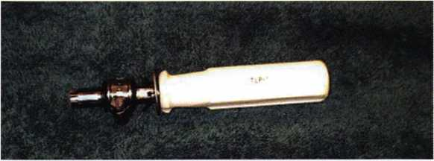

A common tubular pick, but with a piece of hose and a small hose clamp to provide  
minute adjustments to the tension.

I’ve told you that I thought the flexibility of the fiber pick was a great idea, so immediately I attempted to cobble something together along those lines, which was more akin to our “conventional” picks. I took a plastic coffee can cover and cut out a nice hook pick.

I assumed that the material would be flexible, yet fair­ly rigid, and that with just a bit of ingenuity I would have surpassed the research that Pickmasters had done. WRONG. First of all, the pick was far too thick to enter the keyway of most locks. By the time I had thinned it down to accommodate the keyway, most of the rigidity was lost, and it was useless. (I should probably stick to writing articles, rather than inventing.) In any case, my efforts to supplant the existing product stopped there.

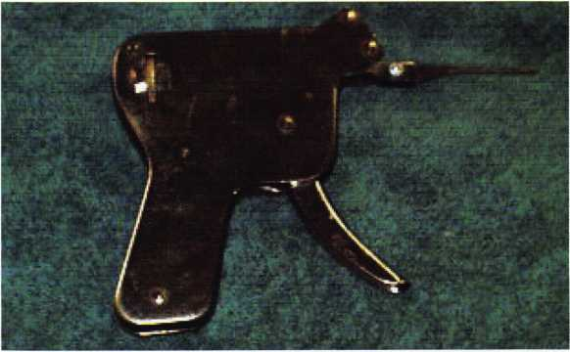

A pick gun. Most locksmiths own one, but use it infrequently.

I will close by stating three facts. First, there are tried  
and true picks that work in a wide range of situations  
for a majority of us. The fact that these have become  
staples of our industry proves their worth. Secondly, there are picks that fit  
specific needs, and are purchased and used only when these specific needs  
arise. Thirdly, there are those on the cutting edge who develop products in  
hopes of having them supplant or adorn themselves next to our normal sta-  
ble of picks. As is the case with any product, those that survive are those that  
prove to be valuable in a wide variety of applications.

I am glad to see some unique innovations in the art of picking. I would chal-  
lenge any manufacturer to step up to the developments that Pickmasters have  
made, and to move the industry into the 21st century. After all, in life it  
becomes increasingly clear: what is not growing is dying. I can only ask that  
we all do our part to help the industry grow. I sincerely hope that my ram-  
blings on something as common as the lock pick have inspired us all to take  
another look at something that we take for granted more often than not.

As Glen Campbell and Roy Clark would say: “I’m a pickin’... and I’m a  
grinnin’!” Keep picking and grinning when your tools do the job they were  
designed to do!

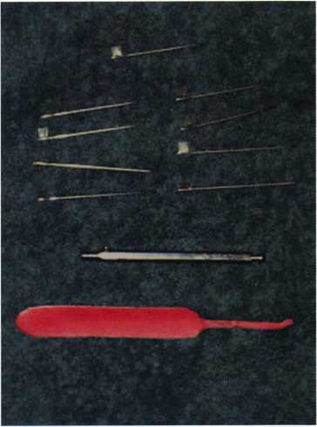

A few fiber picks, and the detachable handle. Below  
these is the author's feeble attempt to cobble together  
something more familiar out of a flexible material:

It was pretty much a complete failure!

Keynotes • December 2004

Safe Data Electronic Index-Why Do I Need It?

By: Jym Welch, CPS

Many of us strive to be on the cutting edge of tech­nology. The problem has always been knowing where the edge is. Greg Perry has constructed a program that helps to define that edge. Many of us have reams of magazine clippings, snapshots of safes, stacks of bul­letins from ALOA, SAVTA, NSO, Boxman, Locksmith Ledger, The National Locksmith, etc., and shelves filled with magazines from years past. We also have megabytes of info stored and used disc space on a PC or Laptop. With these massive amounts of infor­mation, how do we retrieve this information quickly? Mr. Perry has constructed a database that will allow those questions to be answered in a very short time. The Safe Data Electronic Index should be a lynch pin for anyone’s computer-based library.

Locating correct information quickly is the key to any safe opening. Spending less time researching for that information is a godsend. When you spend less time in researching, the time on the job is reduced. This translates to real profits for your company. No longer should you have to send out a tech to “look over” the job or pay him to spend hours in unproductive work due to inaccurate information. Every printed article can be located in your library correctly, easily and accurately. This program is simple to install, navigate, and most importantly, edit. It should be the “go to”

program to answer any safe question before sending out a technician on a safe call or flipping through books endlessly trying to remember where you saw that picture or article. Aside from locating written articles, it comes with hundreds of photos to help you decide what your customer has and it will help you to price the job properly. Is the cost worth the capital invested? It is if you are spending more time exploring and drilling holes in a safe hoping you’ve gotten it right rather than researching the correct information and opening it in a small percentage of the time.

There are several databases on the market and each one has its merits. Investing in a system that utilizes the information within your reach creates a favorable profit margin on each safe your technicians open. Updating any database requires an ongoing invest­ment that is part of business operations. Money wast­ed is profit lost, so correctly investing in a system that shows you where to find information that you have in another form controls your loss column and maxi­mizes your profit column. Safe openings done incor­rectly can be time consuming and costly ventures. By making use of the Safe Data program and acquiring the proper equipment, these expenditures will turn into profits, customer satisfaction, and employee per­formance that each business owner desires.

**26**

Keynotes • December 2004

**Email: glmperry(a)iiuuisp.com for unlock code Greg Perry 2003**

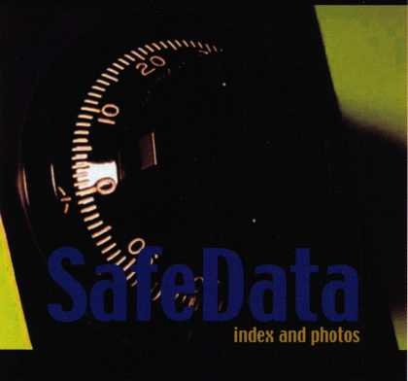

SafeData

Greg Perry, CML, CPS

Open up your library! SafeData allows you to find the information you've  
invested in, fast.This one program has over 8500 listings of magazine, books,  
ClearStar Security Network posts and my personal library. Each listing includes not  
only the book or magazine, the issue, the title, the author and the page, but it also  
lists the lock and the hand of the lock (when available). SafeData lists patent dates  
and other trivia that may help in identifying a container or lock.

SafeData also has picture folders representing over 90 different manufactures of  
safes and locks with over a thousand pictures. Some models include a text file giv-  
ing general information on size and relock locations. Plus you can add your own  
information and update it yourself or purchase the annual updates.

SafeData is available exclusively from ALOA. Normal price for this CD is $249.95.  
Price includes two installs! Put it on your desktop and your laptop.

Special Introductory offer

includes your first update!

$199.95

To order contact ALOA (800) 532-2562

K-12 Medical Records Secured

Under the Watch of the E-Plex 5000

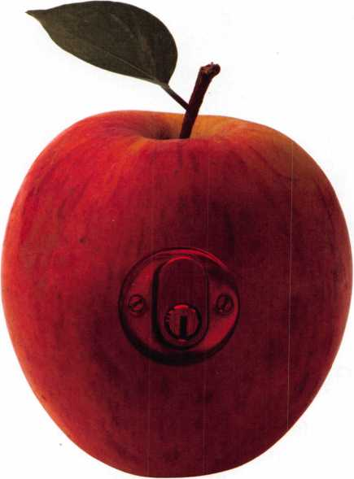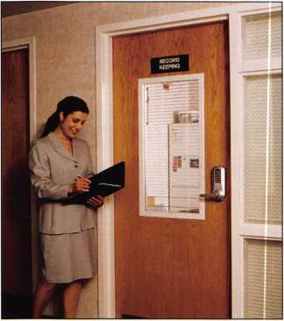

The Winston-Salem Forsyth County School System is one of the largest in the  
Southeast, and includes three schools dedicated to special needs children. These  
schools are responsible for educating the areas physically and mentally disabled  
children in accordance with Federal and State regulations and standards. One of  
the most important priorities in these institutions is security - particularly with  
regard to the medical records that are kept on site. The security of these records  
has been the subject of Federal legislation during the past ten years, including  
HIPPA, and The Medical Records Confidentiality Act, which both took steps to  
ensure the privacy of the subjects of the records.

The Lowrance School in downtown Winston-Salem is unique, in that it maintains  
case files for its students, in addition to countywide records of all students requiring

**28**

Keynotes • December 2004

900 Series

Kaba Access Control continues to offer you a simple, strong and secure pushbutton lock alternative, even in today’s high tech world. With over 40 years of proven per­formance, you can count on Simplex to handle all of your access control needs.

* Keyless convenience

no keys or cards

* Easy to install

no wiring or computers

* Easy to maintain

no batteries to replace

* Easy to manage

one code, can be changed in seconds

The Simplex 900 Series offers an economical solution for both commercial and residential applications. An all-metal, weather resistant design makes it perfect for any location. The lock can be mounted above an existing lockset or used alone. Its rim mounted latch and field reversible design make installation quick and simple.

Available in a variety of options and models:

Deadbolt - 1" throw, manual relock

Deadlocking Latch - %“ throw, automatic relock with latch holdback

Variable Door Thickness - available for doors V/e" to 2'/2u

Optional Key Override - key access for emergency and service personnel

physical therapy. This creates two access control chal-  
lenges: only select teachers and a Case Manager at the  
school may access the records of Lowrance School, while  
only county physical therapy employees can access county-  
wide records. In addition, the county employees are tran-  
sient, moving among schools throughout the county

during the day, based upon each school’s par-  
ticular needs. They come and go at irregu-  
lar intervals, providing them with multiple  
keys to multiple schools can create a night-  
mare for any security manager.

The Lowrance School has recently discov-  
ered the solution to these access control  
challenges in the E-Plex 5000 by Kaba  
Access Control. The E-Plex 5000 is an  
electronic lock that builds on the ease of use  
and convenience of Simplex® mechanical  
pushbutton locks, and combines it with the  
enhanced functionality of an electronic  
lock. The end result is a lock that proves  
an electronic lock can be easy to install,  
easy to manage, and easy to use.

Principal Ron Caviness decided to use the E-

Plex 5000 on both medical records rooms in the

school. The E-Plex 5000 provides the additional security  
of multiple user access codes, and it eliminates the hassles  
of key management.

Managing the E-Plex requires only that the lock manager  
assign users an access code. Users can be added and delet-  
ed in seconds. When a physical therapist forgets a code,

the code is simply deleted and a new code assigned. When  
an employee leaves the school system, there is no need to  
collect keys, and no potential need to re-key.

Overcoming Key Issues

Principal Caviness discussed key control as an ongoing issue in public schools. He noted, “When someone loses a key, you have two choices: you can re-key the entire facili­ty, or you can sit back and hope that the person who finds the lost key doesn’t want to cause trouble in your school.”

If the budgeting concerns of public schools were not a fac­tor, Principal Caviness said he would re-configure the entire school to E-Plex 5000 locks, because they give him

the ability to easily replace codes and users. Replacing a  
lost key is much more involved, and for institutions that  
operate without a locksmith on staff, can be very expen-  
sive.

E-Plex 5000 Features

The E-Plex 5000 is loaded with features, many of

which are directly applicable to the Lowrance  
School. Americans with Disabilities Act compli-  
ance is a great advantage at a school that is sub-  
ject to Federal and State regulations relating to  
special needs education.

Multiple user codes are also a big plus. The user  
groups at the school can grow significantly, as  
each lock accommodates up to 100 individual  
access codes. If each code is assigned to a group  
of users, the number of potential users is virtually  
unlimited. A Service Level User is another  
optional programming level, which allows the  
user access to a door once,

or multiple times over a 24  
hour period. This is espe-

cially useful for organizations

that utilize outside maintenance personnel in their

facilities.

Ease of use also stands out as a prominent feature in the  
Lowrance School. The two lock managers - Principal  
Caviness and the school’s Case Manager, are not lock-  
smiths or security personnel by trade, but due to limited  
budgets, they perform these duties on any given day. A  
system that makes this job more manageable is welcome.  
Proven durability and reliability are key factors, given the  
Lowrance School’s surroundings. It is classified as an inner  
city school, which means it is subjected to many security  
rigors not commonly encountered among suburban  
schools.

The feedback from the staff at Lowrance School, Principal  
Caviness, and the county physical therapy employees, has  
all been very good. Educating special needs children pro-  
vides one of the greatest educational challenges of the  
twenty-first century, but thanks to the E-Plex 5000, the  
security of Lowrance and Forsyth County’s medical records  
for special needs children no longer complicates it.

**30**

Keynotes • December 2004

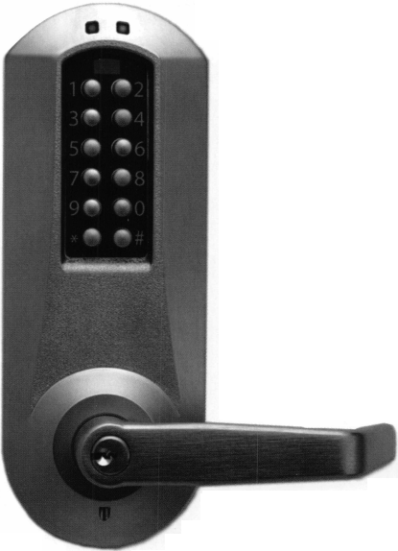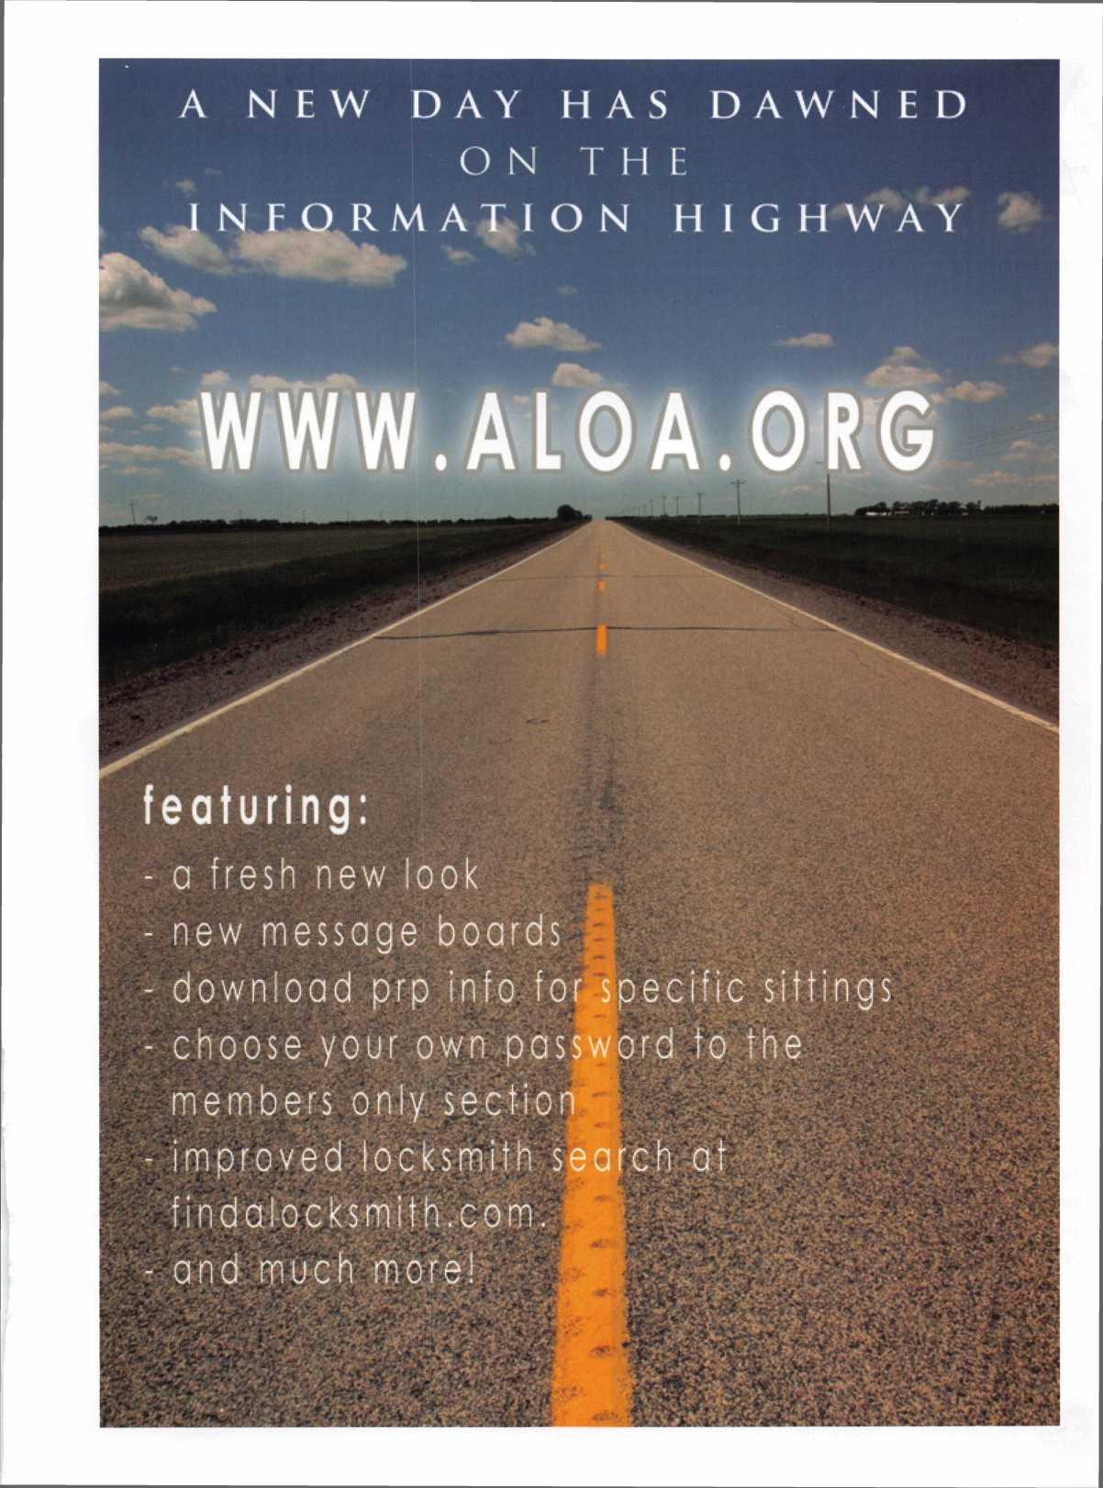

What Does Your Yellow Page Ad Say About You?

By: Greg Perry, CML, CPS



1 like to travel- usually a few times a year. When I stay in a hotel, I almost look in the phone book at the local lock­smith ads. Call it curious or crazy. (My wife thinks the lat­ter.) I look to see how the ads look. I’m also looking to see how large the ads are and how they much information they include. I wonder how much money is expended every month? Do the ads really generate enough new revenue to justify their ad size? This article explores some of my thoughts. More importantly, I’ll ask some questions of you. I’m not going to advocate getting rid of Yellow Page ads completely, but you should realistically evaluate what you

hope to achieve and whether the ad is worth the money you spend. Our Yellow Pages salesperson shows up every July or August for the October directory. We discuss the pros and cons, change a few things and always with the half page ad.. .but why?

Our current yellow pages ad offers a free gift if you men­tion the ad. This is not a new tactic but our salesperson suggested it. He claimed that over 80% of customers find a locksmith from the Yellow Pages. Our ad has been out a month and so far, no one has mentioned the ad. Do peo­ple really read the ad or do they only look for the nice

Keynotes • December 2004

>1



f

fS

**155**

3-9600

>2-8500

1-0744

62-1650



4

A

j re

4-5950

name or 24 hour service. What about quality? And how could a customer determine quality from a ad? One way is to belong to include the ALOA or SAVTA logo in your ads. It lends credibility and shows that we care enough about our craft to belong to a professional association. Given the choice, I believe most people would choose the association member over the nonmember.

Perhaps one of the more important questions to ask about yellow page ads is, do you want the call? If you emphasis automotive or residential work the answer is probably, “yes”. If you prefer commercial/industrial or institutional work, the Yellow Pages are probably a waste of money. I’ve even seen ad that say in bold print “We Do Not Do Automotive Work”. Why spend the staff hours answering phones, only to refer the calls to some­one else? We prefer the steady repeat customer to the one-shot lockout, when given a choice. We find that some lockout calls interrupt other scheduled work and can easily mess up a carefully-planned schedule. After-hours calls are not a big deal, although I don’t relish being woken up at 3 a.m. to open a car! When call volume is slow these calls can add a few dollars to the till, but I don’t believe that for us these calls do not justify the expense of a Yellow Page ad.

A recent business trip found me in a hotel room with nothing better to do that tear apart a few ads. One business claimed that they specialized in,

“Ford 10 pin igns. Replaced and foreign car igns.” Wondering if the average consumer would even understand this, I asked a mechanical engineer and her husband sitting next to me on the plane ride back if it made any sense to them. They figured the statement it had to do with “those button on the outside of the door”. The ad mentioned PIN (or Personal Identification Number). Another ad mis­



spelled several products referring to, Guardall and Century safe servicing”. I wonder why no one

proofread the ad. If the customer has a Gadall or Sentry (correctly spelled) safe, would they call this shop? If the customer recognized the Spelling error, what quality of work might be expected out of a shop who can’t get the name correct?

If you decide you need a large ad and live in a large city, have someone who doesn’t know your business look through the phone book to see if they can find your ad and ask them the following questions:

* Does the ad appeal to you?
* Would you call this business or someone else in the book?
* Does your ad make sense or use jargon that only someone in the industry might under­stand?

I would also suggest that you do some research. Question the statements included in your ad. For example, why limit yourself to a particular brand, unless you only want to service that brand? Look up plumbers, electricians, or some other trade in the phone book. Which ads catch your eye? Who would you call and why?

One of my biggest pet peeves about an ad is that some companies about an ad is that some compa­nies seem to specialize in everything. How is that possible? If you look up “specialize” in the diction­ary it says, “to concentrate one’s effort in a field”. There are a few areas I focus on a more than others but the truth is, most locksmiths do it all-from alarms and automotive to safes. Not listing each “specialty” Doesn’t make me less-competent techni­cian any more than my family doctor, who is comr petent to treat me for most illnesses. If you have a true specialty, list it. But remember, someone who

Keynotes • December 2004

needs safe work may call another provider if, for example, your ad says you specialize in automotive.

Try to tailor your ad to your business but keep your state­ments as broad as possible. It may be better to tell some­one, “no we don’t do that” than to lose the call because you didn’t list a particular brand name or type of work in your ad. My own opinion is less is more. In advertising, this concept is called “K.I.S.S.” (Keep It Simple Stupid). Give your customer enough information to make them want to call you, not enough to question whether you are the right shop to call.

Your goal should be customer satisfaction and making yourself money, not making the phone company rich with your advertising dollars. Choose your advertising and Yellow Pages ads wisely. Make your marketing reflect the types of work you want. Do you cater to commercial accounts that provide long term repeat business or do you

work in a vacation resort where lost keys and car lockouts are the most common call? I spoke with one locksmith who used to have the largest ad in the phone book. It cost $60,000 per year. To track the calls generated, he added a special phone number that only was published in this ad. Most of the calls were from customers who were compari­son price shopping by calling each ad in the book. The locksmith canceled the large ad, kept the small listing, and hired a salesperson to generate significantly more profitable business.

We plan to continue monitoring our ad in the Yellow Page and cut it, if business does not increase because of it. I would rather concentrate on other types of advertising. You too, might want to reflect on whether your ad is increasing your bottom line. When I come to your town, I’ll be look­ing at your ads. Until then, look at your own and your competitors’ ads. What does your ad say about you? Who would you call?

**THE HINGE DOCTOR**

**by GKL Products**

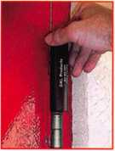

**HA1 For  
Standard**

**Commercial**

**4-1/2" x 4-1/2’**

**Butt Hinges**

**HA2**

***"The HULK'***

**For Residential**

**COMING IN  
SEPTEMBER**

**HA3**

**For Ball- Bearing**

**Commercial Hinges**

**The Hinge Doctor is a great way to repair those sagging metal  
doors. Slip the tool over the hinge and open the door an inch**

**or two past the point where the tool binds against the  
hinge, remove the tool and check the door,**

**which should now be working properly.**

**If you're a locksmith these tools  
will turn a profit the 1st time you  
use them!  
Uses - schools, hospitals,**

**commercial buildings, storefronts**

**with butt hinges, office doors, new**

**construction, door alignment, sagging**

**doors, jail cells, anywhere there are  
commercial grade hinges.**

**HA4**

**For Prison**

**& Institutional**

**Hinges &**

**Spring Hinges**

Over

**10,000**

Satisfied

Customers

US Patent **#6450003**

**[www.hingedoctor.com](http://www.hingedoctor.com)**

**800-924-5397**

**34**

Keynotes • December 2004

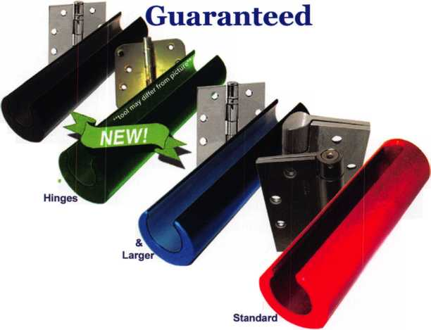

call me.

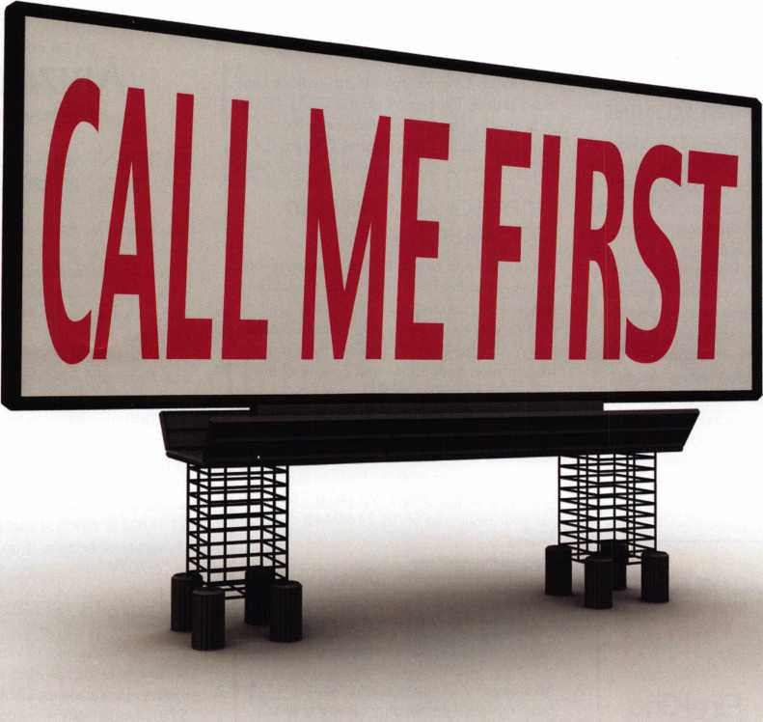

which one catches your attention?

Bigger is sometimes better. And when someone is in need of your services, you want to take every opportunity to make your name prominent in the minds of searching consumers.

Introducing a new advertising solution from ALOA. At our new public locksmith search site, findalocksmith.com, you can now purchase an ad for your business that will shine brightly on the results page whenever someone searches for a locksmith in your zip code. The initial cost is only $30.00, and each additional zip code you add is only $5 extra. Don't miss this great opportunity!

Call Kim Hammond at 817-645-6778 for details.

Spaces for each zip code are limited. Call to reserve yours now!

Classifieds



EMPLOYMENT

RELOCATE TO "THE LAST FRONTIER"

Action Security, Inc. is a 41-year-old security company that is interested in hiring you. Its serv­ices include electronic security: bank/credit union security; wholesale products; hollow metal fabrication; contract hardware; retail security centers; and professional locksmith services. We have three retail locations andoffer statewide service. Opportunity and professional growth is encouraged. Ideal candidate must be neat in appearance, people oriented, self motivated ahard working. Applicants must possess a good driving record and pass drug testing.We will train the right candidate. Action offers full bene­fits package; competitive wages, medical insur­ance, paid vacation & sick days, continuous education, and profit sharing. Please send resume or email [info@actionsecurity.com](mailto:info@actionsecurity.com) if interest­ed in relocating to Alaska.

IN-STOCK...MORE SAFES

***FREE Freight Program***

***(30 States)***

**AMSEC** FireKing **Racial** HAYMAN MEIUNK **yiCTOfi**

**TURn** to

**WHOLESALE SERVICE**

800-848-9790

EXPERIENCED LOCKSMITH

Established & expanding company in center New Jersey is seeking experienced help in resi­dential/ commercial/auto/access control/safe work. Top pay for top mechanics along with medical, dental, paid vacation, no night calls. Apple Locksmith, 4030 Route 9 South, Morganville, NJ 07751, 732-970-1500 or fax resume to 732-970-9725 - Attention: Andy or Jack.

FOR SALE

Key Blanks: Original Yale, Hurd, replacement Independent, Graham, Keil, misc. mfg. For a list or to specify your needs email or write: [c- cameron@triad.rr.com](mailto:c-cameron@triad.rr.com), Charles Cameron, CML, 2818 Sherwood St., Greensboro, NC 27403.

PROFESSIONAL EXPERIENCED LOCKSMITH(S) WANTED

We are in need of experienced and motivated locksmiths to help in any or all of the following: residential, commercial, auto, access control. CCTV experience a plus. Our shop is located in North Atlanta, GA and services the entire metro Atlanta area both inside and outside of the perimeter. Must have a clean criminal and driv­ing record, professional attitude, and be able to work with little or no supervision. Must supply references and background check. Competitive pay based on experience. Flexible hours. Interested Parties should call (404) 788-6079 or fax your resume to (770) 246-0448 or email resume to

[lockjob@hotmail.com](mailto:lockjob@hotmail.com).

**The University of**

**Arizona.**

**Tucson Arizona**

ASSISTANT MANAGER FOR ACCESS CONTROL - RESIDENCE LIFE

Responsible for the development, planning & coordination of activities related to all aspects of access control for Residence Life. Will establish & maintain a master key system for all Residence Halls & will supervise Residence Life key desk personnel & operations in direct support of Lock Shop Operations, Card Access & Emergency on call. Successful candidate must pass criminal background evaluation. Salary: $42,000 - $47,000 annually + outstanding UA benefits.

For full details & to apply, complete the online application for job# 31790 at [www.hr.ari- zona.edu](http://www.hr.ari-zona.edu). Be prepared to attach resume & letter of interest. Review of materials will begin 1 1/1/04 & continue until position is filled. The University of Arizona is an EEO/AA Employer- M/W/D/V.

**HQ** SECURITY GROUP, INC.

A&B Security Group is a well established, fast growing locksmith security company in Las Vegas. We are looking for the right individuals to grow with us and become part of the future. If you are looking for a future, not just a job, then we want you!

* Medical Benefits
* 401 K Program with Matching Dollars
* Paid Vacation
* Good Work Environment
* Advancement
* Established Company

For a confidential interview, call Gary of Phil - 702-362-0222

LOCKSMITH - RESIDENCE LIFE

Repairs, installs and services locks and related hardware to include electronic access control systems for Residence Life buildings. Salary: $28,144 annually + outstanding UA benefits. For full details & to apply, complete the online application for job# 31811 at [www.hr.ari- zona.edu](http://www.hr.ari-zona.edu). Be prepared to attach resume. Review of materials will begin 1 1/1/04 & con­tinue until position is filled. The University of Arizona is an EEO/AA Employer-M/W/D/V.

2005

EAST COAST REGIONAL

LOCK & SECURITY SHOW

(CLASSES, TRADE SHOW, AND BANQUET)

March 3rd thru March 6th Crowne Plaza Meadowlands Hotel

For More Information:

PO Box 2441

Morristown, NJ 07962-2441 Fax 973-538-1588 Or visit our web site at [www.mlanj.org](http://www.mlanj.org)

WANTED TO BUY/SELL

WHOLESALE SAFE DEPOSIT LOCKS

Diebold, Herring Hall Marvin, llco, LeFebure, Mosler, Precision, S&G, Security Corp, Yale. Now available Safe Deposit Boxes Sections, Doors, Hinges and Bond Tins. Vault Doors, Safes, Night Depositories, Vault Lockers and One Inch Plate Steel are also stocked items. Call WBI (954)484-2404 or [Sales@WBI.US](mailto:Sales@WBI.US).

EQUIPMENT FOR SALE

Scotsman #747XU Tubular Key Machine (cuts to codes or dupli­cates) with manual, used very few times - $500.00 HPC general code book 1A - $50.00 - A set Reed code books 1-14 with index $500 for set - Reed code book #5 Padlocks $50.00 - Baxter code books 1,5, 1 1, 19, 20, 22, 23, 24, 27, 28, 29, 30, 31, 34, 35, 36, 37, 38 updated through 2003 $500.00 for set - Kent-moore Vats key interpreter $100.00 - A-l Auto key punch set with case (PAKSSB) $500.00 - ASP Auto Cap Assortment #A0-002 (with the original face caps) $100.00 - An inventory of Dead Bolts, lock sets etc. Listing will be sent if you will send a SASE (business size). All items are F.O.B. Narvon, PA. Byron A. Rohrbach RL, 2543 School House Lane, Narvon, PA, 17555-9004. Phone (717) 445-1240.

FOR SALE

Al-Pak-A-Punch III never used in carrying case, with 7 auto kits (Ford FA/FB/Ford 10 Cut/GM 6 Cut/Chrysler F/M/Y 60000/Chrysler EP/ES/Chrysler S/L all never used! $400.00 for all. Both in carrying cases. 860-423-5604.

Classified Advertising Policy

Classified advertising space is provided free of charge to AiOA members and for a fee of $2.00 per word, $40.00 minimum for non members. Classified ads may be used to advertise used merchandise and overstocked items for sale, "wanted to buy" items, business opportunities, employment opportunities/positions wanted and the like. Members or non members wishing to advertise services or new merchandise for sale may purchase a "Commercial Classified Ad" for a fee of $4.00 per word with a mini­mum of $ 100.00. Each ad will run for two issues. For blind boxes there is a $10.00 charge for members and non members. All ads must be submitted in writing to the Advertising Sales Department via fax at 817-645-7599 or through an email to [adsales@aloa.org](mailto:adsales@aloa.org) by the fifteenth of the month two months prior to issue date. ALOA reserves the right to refuse any classified advertisement that it deems inappropriate according to the stated purpose of the classified advertising section.



**SAFE CORPORATION**

Viking Stainless

Fire & Burglary Protection  
State of the Art Composite Fill

Strong • Functional • Attractive

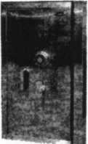

Available in 10 sizes  
to Fit Every Need

1

See us at [www.a-bsafecorp.com](http://www.a-bsafecorp.com)

1*-*800*-*253-1267

Fax 856-863-1208

CALL FOR YOUR CATALOG TODAY

25+ Function

Multi-Tool

**—** Lifetime Warranty **—**

LOCKSMITHS ONLY

* 25 Functions  
' Services Schlage, Baldwin  
Corbin/Russwin, Lori,

Adams Rite, Master

padlocks, Medeco, Arrow,

Jackson crossbars and

many more!

Call Toll Free—

888-634-LOCK

[www.lockmantools.com](http://www.lockmantools.com)

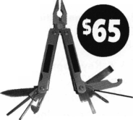

Distributor

**1 st In Hardware, Inc.**

Phone: 866-397-9900 Fax: 866-646-0045 www. 1 stinhardware.com

**ADI Inc.**

Phone: 631-692-1000 Fax: 631-692-3011

**Accredited Lock Supply Co.**

Phone: 800-652-2835 Fax: 201-865-0030 [www.acclock.com](http://www.acclock.com)

**Ace Lock & Security Supply**

Phone: 800-223-5625 Fax: 908-688-2442 [www.acelock.com](http://www.acelock.com)

**Andrews Wholesale Lock Supply**

Phone: 717-272-7422 Fax: 717-274-8659 [www.andrewslock.com](http://www.andrewslock.com)

**Boyle & Chase Inc.**

Phone: 800-325-2530 Fax: 800-205-3500 [www.boyleandchase.com](http://www.boyleandchase.com)

**Chinrose International**

Phone: 503-357-7553 Fax: 503-357-5522 [www.chinrose.com](http://www.chinrose.com)

**Clark Security Products**

Phone: 888-784-1311 Fax: 619-718-7333 [www.clarksecurity.com](http://www.clarksecurity.com)

**Cook's Building Specialties**

Phone: 505-883-5701 Fax: 505-883-5704

**E. L. Reinhardt Co., Inc.**

Phone: 800-328-1311 Fax: 651-481-0166 [www.elreinhardt.com](http://www.elreinhardt.com)

**Ewert Wholesale Hardware**

Phone: 800-451-0200 Fax: 708-597-0881

**Fairway Supply, Inc.**

Phone: 214-350-0021 Fax: 214-352-4299 www. fa i r way su p ply.com

**Foley-Belsaw Company**

Phone: 800-821-3452 Fax: 816-483-5010 [www.foley-belsaw.com](http://www.foley-belsaw.com)

**Fried Brothers Inc.**

Phone: 800-523-2924 Fax: 215-592-1255 [www.fbisecurity.com](http://www.fbisecurity.com)

**Hans Johnsen Company**

Phone: 214-879-1550 Fax: 214-879-1530

**Hardware Agencies, Ltd.**

Phone: 416-462-1921 [www.hardwareagencies.com](http://www.hardwareagencies.com)

**IDN Incorporated**

Phone: 817-421-5470 Fax: 817-421-5468 [www.idn-inc.com](http://www.idn-inc.com)

**Intermountain Lock & Supply**

Phone: 800-453-5386 Fax: 801-485-7205 [www.intermountainlock.com](http://www.intermountainlock.com)

**International Electronics, Inc**

Phone: 800-343-9502 Fax: 617-821-4443

**Dire's Lock & Key Company**

Phone: 303-294-0176 Fax: 303-294-0198

**Direct Security Supply, Inc.**

Phone: 800-252-5757 Fax: 800-452-8600

**Discount Key Machines.Com/Busch**

Phone: 800-332-8724 Fax: 407-363-4666

**Doyle Security Products**

Phone: 800-333-6953 Fax: 612-521-0166 [www.doylesecurity.com](http://www.doylesecurity.com)

**Dugmore and Duncan, Inc.**

Phone: 888-384-6673 Fax: 888-329-3846

**Jo Van Distributors**

Phone:416-752-7249 Fax: 416-752-7282 [www.jovanlock.com](http://www.jovanlock.com)

**Lockmasters, Inc.**

Phone: 859-885-6041 Fax: 859-885-7093 [www.lockmasters.com](http://www.lockmasters.com)

**Locks Company**

Phone: 800-288-0801 Fax: 305-949-3619

**Locksmith Ledger International**

Phone: 770-886-0800 Fax: 770-889-7703 [www.lledger.com](http://www.lledger.com)

**M. Zion Company**

Phone: 212-349-8677 Fax: 212-964-0495 [www.mzion.com](http://www.mzion.com)

**McDonald Dash Locksmith Supply**

Phone: 800-238-7541 Fax: 901-366-0005 [www.mcdonalddash.com](http://www.mcdonalddash.com)

**Monaco Lock Co.**

Phone: 800-526-6094 Fax: 800-845-5625 [www.monacolock.com](http://www.monacolock.com)

**Omaha Wholesale Hardware**

Phone: 800-238-4566 Fax: 402-444-1664 [www.omahawh.com](http://www.omahawh.com)

**RA-Lock Company**

Phone: 972-775-6301 Fax: 972-775-6316 [www.ralock.com](http://www.ralock.com)

**Security Distributors Inc**

Phone: 800-333-6953 Fax: 612-524-0166

**Security House**

Phone: 905-669-5300 Fax: 905-660-6313 [www.securityhouselock.com](http://www.securityhouselock.com)

**Security Lock Distributors**

Phone: 800-847-5625

Fax: 800-878-6400

[www.securitylockdistributors.com](http://www.securitylockdistributors.com)

**Shin-An Enterprise Inc.**

Phone: 718-225-5380 Fax: 718-819-0723

**Southern Lock and Supply Co.**

Phone: 727-541-5536 Fax: 727-544-8278 [www.southernlock.com](http://www.southernlock.com)

**Stone & Berg Wholesale**

Phone: 800-225-7405 Fax: 800-535-5625

**The Locksmith Store Inc.**

Phone: 847-364-5111 Fax: 847-364-5125 [www.locksmithstore.com](http://www.locksmithstore.com)

**Timemaster Inc.**

Phone: 859-259-1878 Fax: 859-255-0298 [www.time-master.com](http://www.time-master.com)

**Top Notch Distributors, Inc.**

Phone: 800-233-4210 Fax: 800-854-4146 [www.topnotch.bz](http://www.topnotch.bz)

**Turn 10 Wholesale**

Phone: 800-848-9790 Fax: 800-391-4553

**U.S. Lock Corp.**

Phone: 800-925-5000 Fax: 800-338-5625 [www.uslock.com](http://www.uslock.com)

**Wilson Safe Company**

Phone: 215-492-7100 Fax: 215-492-7104 [www.wilsonsafe.com](http://www.wilsonsafe.com)

Manufacturer

**A & B Safe Corporation**

Phone: 800-253-1267 Fax: 856-863-1208 [www.a-bsafecorp.com](http://www.a-bsafecorp.com)

**ABUS Lock Company**

Phone: 800-352-2287 Fax: 602-516-9934 [www.abus.com](http://www.abus.com)

**Access Security Products Ltd.**

Phone: 905-337-7874 Fax: 905-337-7873 [www.access-safe.com](http://www.access-safe.com)

**Adams Rite Mfg Company**

Phone: 800-872-3267 Fax: 800-232-7329 [www.adamsrite.com](http://www.adamsrite.com)

**Adesco Safe Mfg. Company**

Phone: 800-694-9340 Fax: 562-408-6427 [www.adesco.com](http://www.adesco.com)

**Adrian Steel Company**

Phone: 800-677-2726

Fax:517-265-5834

[www.adriansteel.com](http://www.adriansteel.com)

**All Five Tool Company, Inc.**

Phone: 860-583-1691 Fax: 860-583-4516 [www.all5tool.com](http://www.all5tool.com)

**American Lock Company**

Phone: 708-534-2000 Fax: 708-534-0531 [www.armericanlock.com](http://www.armericanlock.com)

**American Security Products**

Phone: 909-685-9680X1083 Fax: 909-685-9685 [www.amsecusa.com](http://www.amsecusa.com)

**Best Metaline Inc.**

Phone: 714-441-0098 Fax: 714-441-0977

Keynotes • December 2004

associate

members

**Bianchi USA, Inc.**

Phone: 800-891-2118 Fax: 216-803-0202

**Buddy Products**

Phone: 800-886-8688 Fax: 312-733-8356 [www.buddyproducts.com](http://www.buddyproducts.com)

**CCL Security Products**

Phone: 800-733-8588 Fax: 847-537-1800

**COMPX Security Products**

Phone: 864-297-6655 Fax: 864-297-9987 [www.compxnet.com](http://www.compxnet.com)

**D&D Technologies (USA), Inc.**

Phone: 714-677-1300X292 Fax: 714-677-1299 [www.ddtechusa.com](http://www.ddtechusa.com)

**DETEX Corp.**

Phone: 800-729-3839 Fax: 830-620-6711 [www.detex.com](http://www.detex.com)

**DORMA Architectural Hardware**

Phone: 717-336-3881 Fax: 717-336-2106 [www.dorma-usa.com](http://www.dorma-usa.com)

**Datakey Electronics**

Phone: 952-746-4066 Fax: 866-289-4212 [www.datakeyelectronics.com](http://www.datakeyelectronics.com)

**Don-Jo Manufacturing, Inc.**

Phone: 978-422-3213 Fax: 978-422-3467 [www.don-jo.com](http://www.don-jo.com)

**Door Controls International**

Phone: 800-742-3634 Fax: 800-742-0410 [www.doorcontrols.com](http://www.doorcontrols.com)

**ESP Lock Products Inc.**

Phone: 800-434-8960 Fax: 978-562-9859

**FireKing Security Products**

Phone: 800-457-2424 Fax: 800-896-6606 [www.fkisecuritygroup.com](http://www.fkisecuritygroup.com)

**Framon Manufacturing Company Inc.**

Phone: 989-354-5623 Fax: 989-354-4238 [www.framon.com](http://www.framon.com)

**HPC, Inc.**

Phone: 847-671-6280 Fax: 847-671-6343 [www.hpcworld.com](http://www.hpcworld.com)

**HY-KO Products Co.**

Phone: 330-467-7446 Fax: 330-467-7442

**Hammerhead Industries, Inc.**

Phone: 805-658-9922 Fax: 805-658-8833 [www.gearkeeper.com](http://www.gearkeeper.com)

**Ingersoll Rand SSA**

Phone: 317-613-8025 Fax: 317-613-8068 [www.schlagelock.com](http://www.schlagelock.com)

**Jet Hardware Mfg., Co.**

Phone: 718-257-9600 Fax: 718-257-0973 [www.jetkeys.com](http://www.jetkeys.com)

**KABA ILCO Corp.**

Phone: 252-446-3321 Fax: 252-446-4702 [www.kaba-ilco.com](http://www.kaba-ilco.com)

**KEY-BAK/West Coast Chain Mfg.**

Phone: 909-923-7800 Fax: 909-923-0024 [www.keybak.com](http://www.keybak.com)

**Keri Systems Inc.**

Phone: 408-451-2520 Fax: 408-441-0309 [www.kerisys.com](http://www.kerisys.com)

**Knaack Manufacturing Co.**

Phone: 800-456-7865 Fax: 815-459-9097 [www.weatherguard.com](http://www.weatherguard.com)

**LAB Security**

Phone: 800-243-8242 Fax: 860-583-7838 [www.labpins.com](http://www.labpins.com)

**La Gard Inc.**

Phone: 310-325-5670 Fax: 310-325-5615 [www.lagard.com](http://www.lagard.com)

**Lock America, Inc. dba L.A.I. Group**

Phone: 714-373-2993 Fax: 714-373-2998 [www.laigroup.com](http://www.laigroup.com)

**Lucky Line Products, Inc.**

Phone: 858-549-6699 Fax: 858-549-3241 [www.luckyline.com](http://www.luckyline.com)

**M.A.G. Security**

Phone: 714-891-5100 Fax: 714-892-6845 [www.magsecurity.com](http://www.magsecurity.com)

**MUL-T-LOCK USA, Inc.**

Phone: 800-562-3511 Fax: 973-778-4007 [www.mul-t-lock.com](http://www.mul-t-lock.com)

**Medeco Security Locks**

Phone: 540-380-5000 Fax: 540-380-5010 [www.medeco.com](http://www.medeco.com)

**ROFU International Corp.**

Phone: 253-922-1828 Fax: 253-922-1728 [www.rofu.com](http://www.rofu.com)

**Rutherford Controls Int'l Co.**

Phone: 757-427-1230 Fax: 757-427-9549 [www.rutherfordcontrols.com](http://www.rutherfordcontrols.com)

**STRATTEC Security Corp.**

Phone: 414-247-3415 Fax: 414-247-3692 [www.strattec.com](http://www.strattec.com)

**Sargent & Greenleaf, Inc.**

Phone: 800-826-7652X201 Fax: 859-885-3063 [www.sargentandgreenleaf.com](http://www.sargentandgreenleaf.com)

**Sargent Manufacturing Co.**

Phone: 800-727-5477 Fax: 888-863-5054 [www.sargentlock.com](http://www.sargentlock.com)

**Schwab Corp.**

Phone: 765-447-9470 Fax: 765-447-8278 [www.schwabcorp.com](http://www.schwabcorp.com)

**Securitron Magnalock Corp.**

Phone: 775-355-5625 Fax: 775-355-5636 [www.securitron.com](http://www.securitron.com)

**Security Door Controls**

Phone: 805-494-0622 Fax: 805-494-8861 [www.sdcsecurity.com](http://www.sdcsecurity.com)

**Security Solutions**

Phone: 405-376-1600 Fax: 405-376-6870 [www.securitysolutions-usa.com](http://www.securitysolutions-usa.com)

**Townsteel, Inc.**

Phone: 626-858-5080 Fax: 626-858-3393 [www.townsteel.com](http://www.townsteel.com)

**Trine Access Technology**

Phone: 718-829-2332 Fax: 718-829-6405 [www.trineonline.com](http://www.trineonline.com)

**Victor E-lok, Inc.**

Phone: 949-916-1200 Fax: 949-916-1300 [www.victorelok.com](http://www.victorelok.com)

**Videx Inc.**

Phone: 541-758-0521 Fax: 541-752-5285 [www.videx.com](http://www.videx.com)

**YSG Door**

**Security Consultants, Inc.**

Phone: 800-438-1951 Fax: 800-338-0965

Service

Organization

**Allstate Insurance Company**

Phone: 800-859-0247 Fax: 847-326-7509 [www.allstate.com](http://www.allstate.com)

**Cross Country Automotive Services**

Phone: 800-541-2262 Fax: 781-393-0256 [www.argosi.com](http://www.argosi.com)

**Massglass & Door Service**

Phone: 888-742-8837 Fax: 805-497-2255 [www.massglass.com](http://www.massglass.com)

**Webster Safe & Lock Co., Inc.**

Phone: 901-332-2911 Fax: 901-332-2878 [www.webstersinc.com](http://www.webstersinc.com)

Keynotes • December 2004



The results of November's Presidential and Congressional elections bode quite well for the out­look for Association Health Plan legislation in 2005. Below is a quick overview of the new members of Congress who could have an impact on the AHP legislation when it is reintroduced next year. Obviously, President Bush's reelection to the White House is a huge plus, given his strong support for the AHP legislation. Moreover, the President's unex­pectedly strong showing in the popular vote (he won by approximately 3.5 million popular votes and is the first president to garner 50% or more of the pop­ular since his father did so in 1988) should provide him with substantial political capital which he can use to put pressure on Senators that have so far refused to support the AHP bill.

In the Senate, the elections have improved the out­look for AHP legislation substantially. Republicans scored a net gain of 4 Senate seats, which will pro­vide them with a 55-44-1 majority in the new 109th Congress, which convenes in January, 2005. Most importantly, Senate Minority Leader Tom Daschle (D- SD), an opponent of the AHP bill, was defeated by former Representative John Thune (R), who support­ed the bill during his tenure in the House. Several other incoming Senators have supported the AHP during their tenure in the House: Jim DeMint (R-SC); Johnny Isakson (R-GA); David Vitter (R-LA); and Richard Burr (R-NC). These five new Senators, who have supported AHPs in the past, replace outgoing Senators who did not support the bill, so this is a swing of five votes in favor of the bill!

Another new Senator, Mel Martinez (R-FL), is a for­mer Bush Administration cabinet official who replaces outgoing Senator Bob Graham (D-FL), and this hopefully will be another vote pick-up for the AHP bill!

Senator-elect Tom Coburn (R-OK) (who is a physician by profession) was not well disposed toward the AHP bill during his tenure in the House. However, during his Senate campaign, he indicated to several organizations that he would support the AHP bill (albeit reluctantly) in the Senate if elected. This would be a huge improvement over his processor, retiring Senator Don Nickles (R-OK), who has been an ardent foe of the AHP bill over the past ten years. The two new Democratic Senators are Ken Salazar (D-CO) and Barack Obama (D-IL). Salazar is Hispanic and has a reputation as a moderate Democrat, whereas Obama, an African-American, has the reputation of a traditional liberal and has an interest in health care issues. Given our past suc­cess in attracting support for the AHP bill from both moderate and liberal Democrats in the House, I am hopeful that both new Democratic Senators will be open-minded and might support the bill.

The bottom line is that, while there are still signifi­cant hurdles to be overcome for the AHP bill to pass the Senate, the new Senate with incoming members who have a history of supporting the bill is by far more favorable than any in recent memory! In the House, Republicans netted 3 new seats, thus bring­ing their House majority to 231-201-1 (two seats remain unresolved due to run-off elections in

Keynotes • December 2004

Louisiana). This is the largest elected Republican House majori­ty since 1946. Rep. John Boehner (R-OH), Chair of the House Education and Workforce Committee, has already indicated he plans to move the AHP bill through the House in early 2005, and there should be no difficulty getting another strong bipartisan vote in support of the bill.

Congress will return for a post­election session on November 16 to finalize the 108th Congress. The Senate is expected to make decisions on committee chairs during that week, which should

give us further insight into the make-up of the 109th Congress and the outlook for the AHP legis­lation. Coalition members will be provided with further analysis in this regard in late November/early December. In the meantime, please let me know if you have any questions or comments on the above infor­mation or the elections.

Best regards,

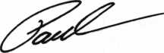

Paul M. Kanitra

LEGISLATIVE

ACTION

NETWORK

You’re a professional  
locksmith, not a  
professional lobbyist.

You can’t be on the steps of every state capitol and walking the halls of the federal government to protect your profession, but...

WE CAN!

The ALOA Legislative Action Network (LAN) needs Your support for the Voice of Our Profession.

The ALOA Legislative Action Network is constant­ly working to influence legislation that’s important to the locksmithing profession. We are working in your best interests to promote legislation that will have a positive impact on our proud profession; while preventing or limiting legislative efforts that are harmful. To continue, we need your help to ensure the success of our legislative program for 2004!

If you contribute $25-$99.99 to the Legislative Action Fund, you automatically become a member of the Legislative Action Network (LAN). The LAN is an important tool in raising the standards of our profession through the legislative process by mak­ing sure that locksmiths have the final say in how our industry will be run. As a LAN member, you will receive:

* The Legislative Action Network Update alerting you to important legislation in your state and around the country.
* Networking opportunities with ALOA members who share the belief that legislative involve­ment is important to the effectiveness of our association.
* A listing of your state representatives and sen­ators including capital and district addresses, and phone and fax numbers on both hard copy and disk.
* A comprehensive guide to lobbying in your state capital, so you can be the "voice of ALOA" to legislators.
* LAN stationary and envelopes for sending offi­cial letters to legislators, lobbying on ALOA’s behalf.
* A lapel pin designating you as a special ALOA LAN member,
* Recognition in Keynotes magazine.
* An invitation to an exclusive reception at the annual ALOA convention for LAN members.

When you donate $100 or more, you become part of the heart of the legislative program through LAN membership and receive the following:

* A reserved place of distinction on the special LAN Council
* Discounts on ALOA bookstore items and a 10 % rebate on all ACE classes.
* Complimentary Legislative Convention mer­chandise.
* It’s easy to do Your part.. .just join TODAY!!

NOTE: Contributions or gifts to the Associated Locksmiths of America, Inc. are not tax deductible as charitable contributions or as business expens­es under IRC - 162(e).



SAFE CORPORATION

MANUFACTURES OF QUALITY DEPOSITORY SAFES AND CHESTS

DISTRIBUTING FROM

WAREHOUSES IN

* LOS ANGLES, CA
* CHICAGO**,** IL
* GLASSBORO, NJ

A & B is now a stocking distributor

for Mutual Safes

featuring

AB-4-30-3S AB-9-2 WS 10-2

Chose from over 75 models in stock

We ship your order within

24 hours

See us

at *[www.a-bsafecorp.com](http://www.a-bsafecorp.com)*800-253-1267  
Fax 856-863-1208

CALL FOR YOUR  
CATALOG TODAY



Keynotes • December 2004

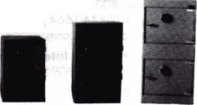

A Tribute to the Best

By: John T. Grist, CML, CPS



“One of my oldest and best friends has died. I will make sure that he will never be forgotten.” -Robert W. Dix Mentor, Ohio

“I found A.J. to be a sincere, generous, delightful and knowl­edgeable person that I had the privilege to meet. Thanks for your time, A.J. Sorry you never enjoyed vegemite on toast from the man down under. Rest peace­fully, A.J.” -Rob McKensie Gold Coast, CAJ Querenscaro Australia

I can remember in the very early years of our business, having a passionate desire to be the the very best locksmith that I could. However, living in this beautiful area of the Northeastern corner of the State of Georgia, I was limited in my educational opportuni­ties. There were no shops or mentors to whom I could apprentice. Until 1983, when I first went into business, there had never been an established locksmith in the county.

Most of what I learned came from real- world experience, training manuals, trade publications, manufacturers catalogs and the like. But the training that meant the most came from experienced role models and mentors in the field. One such person was A.J. Hoffman.

A.J. was a giant of a man in the world of locksmithing and we shared a hobby-the love of lock collecting. In the 1980s, I did not know one other person who collected locks. Thus, it was s surprise for me to meet A.J. at my first Indy Lock Show in 1987.

I am ever mindful of the truth that our days are numbered for this brief stay on earth. Uniformly, it is not always old age that become the factor to blame for our death. None of us are promised tomorrow.

Our memories give us comfort and I would like to remember A.J. by sharing the follow­ing interview originally printed in The Journal of Lock Collecting in the Spring of 2004.

JG Where were you born and raised?

AJ Cleveland, Ohio

JG Which came first...locksmithing or lock collecting?

AJ I started collecting around age 6 for no real reason I've been able to identify. My parents and I collected coins. My mother and I collect­ed insects. And on my own, I collected lots of different things like non-sports trading cards, playing cards, and smoking pipes-of all things. A couple years later I started collecting locks and keys. I lost interest in everything else.

JG

AJ

JG

AJ

JG

AJ

What was the first padlock or key you remem­ber starting your key collection with?

My earliest recollection is a plastic toy I played with as a tot. It had different-colored keys that had to fit into the correct keyhole. Since I still remember that toy, I think it might be what start­ed my interest. As a kid collecting padlocks, I got to know a few locksmiths in the Cleveland area. It was always a nuisance for them to make keys for my locks, so I decided to learn to do it myself. I began rudimentary lock­smithing around age 9. At the age of 10, we moved to an apartment that was within walking distance from one of those Sear's key shops they used to have in the little buildings out in the parking lot. I hung around there after school and on weekends. A locksmith there took me under his wing and I learned to be great with key-blank identification because of the vast variety of keys in the old city of Cleveland.

Bob Dix mentions that he first became acquaint­ed with you while you were still in high school. Tell us how you remember meeting each other.

I don't remember my first meeting with Bob. It was most likely when I worked at the big key shop downtown and he came in as a customer. We sold locks and supplies to other locksmiths so they frequently came to our counter.

Tell us about your first couple of jobs and some of your mentors.

My earliest mentor was Ray James Clarke, an old locksmith from West Virginia who was working at the Sears key shop when I was about 10-12 years old —Before I was legally old enough to work. He shared more knowl­edge than anyone else in my early years. It wasn't just the people who helped this little boy learn, though. They were tearing down hun­dreds of houses across the west side of Cleveland for the construction of Interstate 90. At the time, I used to ride my bike all over there, going from one vacant house to another with my screwdrivers to remove the antique door locks, while the other kids were more interested in sniffing glue (So that's what hap­pened to...). That experience—being able to figure it out all for myself and having no conse­quences if I ruined something, allowed me to learn how locks and cylinders are installed. It was then very easy for me to do routine service calls when the time came, (...the time I was old enough to get a work permit and then old enough to drive.)

Keynotes • December 2004

JG Most of us never had the pleasure of meeting the locksmith in the Sears Tower. Were there others that played an important part in your development as a locksmith?

AJ Jerome Andrews came to work at our shop. I soon realized that he was the knowledgeable locksmith I had ever met so I tried to learn from him, too. Then we jump to Billy Edwards, Jr., CML and Gordon Morris. Billy was Medeco's Key Records Manager at the time and Gordon was the Cylinder Project Manager at Yale. I met them both originally by telephone because the shop I worked in was a direct customer of Medeco and Yale. These two industry experts had all the same interests and specializations as I did at the time so we became fast friends. We talked often and shared information between 1975 and 1982.

I went to my first ALOA show in 1 980 and learned that there was a lot more talent out there than I could ever see just in Cleveland.

JG You are just a few years older than I am and I can honestly say that I have learned much from you as a locksmith. Describe how you gained so much knowledge of locks on your own.

AJ I've always been a specialist, not a generalist. I specialize in cylinders and key systems but I am completely ignorant of door closers, exit devices and most safe and vault work. I'm sure you could teach me a great deal in those areas.

JG While you were working with Corbin Russwin, you produced an extremely useful illustrated cylinder manual. Share what brought you to do that project.

AJ That 95-page book was a labor of love, i was hired to bring cylinder and key expertise to a company that has lost it. I had already done my research into the spider web of depth and spacing variations and corresponding pin length variations because of my 2-day class on servicing interchangeable cores. When I left Lori/Kaba to begin in 1991 at Corbin Russwin, I knew the entire industry needed that informa­tion and more. My main task was to organize much material that is interrelated. Corbin Russwin had the most complex cylinder offering in North America and it had never been docu­mented before. The engineering drawing were a mess. During my 5+ years there, I managed to get the whole mess sorted and organized. The cylinder manual's first edition was con­sumed almost as soon as it hit the streets.

When I left in 1996, the manual was in its 6th edition. Unfortunately, in the transfer of every­thing from Connecticut to the Yale office in North Carolina,, the electronic files were lost and it will be very difficult for them to revise it now.

JG Since you've seen yourself relocating around the country over the years of your life, which part of the country would you say you like the best?

AJ Without question, it is where I live right now in Southern California. I love here but the trouble is that all the commercial lock companies have moved out of California. My marketing job moved to Colorado Springs 4 years ago and I had to transfer to the Training Department in order to stay here because instructors travel and do not have to be based at any of the fac­tories. The day will probably come, though, when I have to leave my California paradise because of job consolidation.

JG When did you attend your first lock collecting show?

AJ My first show as the small one organized at

Sargent and Greenleaf by Harry Miller around 1981. I went because it was within driving dis­tance of Cleveland.

JG You added some museum masterpieces to your collection last year. Do you feel the quality of locks available is diminishing due to a larger number of collectors?

AJ The quality of locks is not diminishing. The big double-edged sword is eBay. Locks that we would never otherwise see are suddenly thrust in front of the world. An H.C. Jones trick lock shows un in Aunt Tilly's attic and her grandson puts in on eBay with a $10 starting bid because he doesn't know what he has. That's the good part. The bad part is that we must inevitably bid against friends we've had for years because everyone is looking for the same quality. No matter what specialty area you choose, there are a few collectors with the same interest and enough money to make eBay life miserable. Bob Dix and I started collecting logo locks 25 years ago when no one else did it. Now, I have to pay hundreds of dollars for a lousy Best logo lock to wrest it from one of three competitor friends on eBay. The same thing has happened to pin tumbler push key locks in the past 10 years. It's astounding.

JG Do you feel that good locks are still a good investment for the average collector?

AJ If collectors pick up nothing else from this inter­view, it's this: Quality keeps its value or increas­es. A cheap lock is always a cheap lock. Don't blow your money on 5 junk locks at $20 each. Wait for one decent one at $100 instead. With very few exceptions, the more money you pay now, the more it will be worth later. Items over $500 are a good investment. At that quality level they are almost sure to increase in quality every year.

One of my first ALOA acquaintances who soon became a dear friend.. .our world has been robbed by your early and sudden death and I will miss you dearly.”

-Ruth Davis Carmel, Indiana

“We have taken several of the classes that A.J. taught over the years.

He always passed on a wealth of knowledge and shared his passion about locks and key sys­tems. He will definitely be missed in the lock- smithing community.” -Charleen Rice Long Beach, California

“When someone rises to the highest levels in any endeavor, they move into the realm of art.

A.J. was an artist in the security hardware field.” -Glenn Younger Ramona, California

Keynotes • December 2004

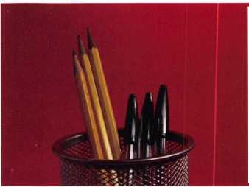

about the authors

**Tom Seroogy**

Tom Seroogy has been involved with automotive locksmith training for many years. He is the co­author (along with Tom Mazzone) of the Guide to Steering Column Service and was the Product Manager for BWD Automotive (formerly known as All Lock). Tom initiated the automotive division of Lockmasters and has developed several new automotive classes for ALOA to help pre­pare locksmiths for the PRP automotive electives. His many years of technical expertise in the automotive field and as a contributor to automotive locksmith education have created a much sought after demand for his popular classes.

**Greg Perry, CML, CPS**

Greg Perry, CML, CPS, has been in the locksmith industry for 20 years. He’s spent half of that time as a field technician for Security Engineering in Ridgecrest, CA. Greg is also a past president of the Desert Counties Chapter of the California Locksmiths Association. He has also won the 2002 Keynotes Author of the Year Award. You can email him at [glmperry@iwvisp.com](mailto:glmperry@iwvisp.com)

**Eric Costley, CRL**

Eric Costley, CRL has been active in the locksmith industry since 1980. He has a bachelor’s degree from Gardnre-Webb University, and has worked in shops in Arizona, North Carolina, and New York. He is currently employed by Bill’s Locksmithing in Elmira, New york. Eric’s hobbies include music and raising tarantulas.



Keynotes • December 2004